**DELTA Version 5.0**

**Concepts / User’s Guide / Diagrams**

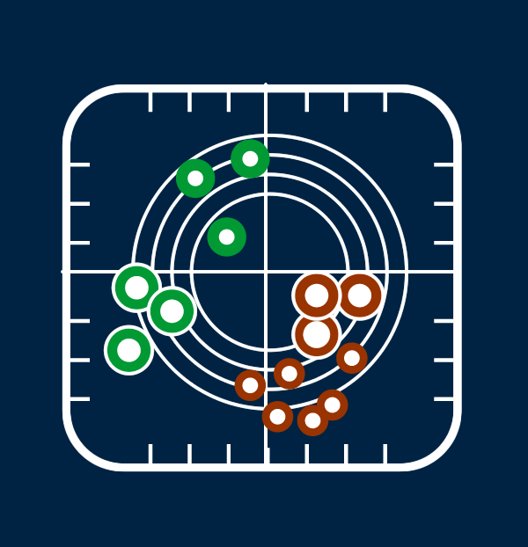

**Authors**

**P. Thunis, C. Cuvelier**

**Contributors**

**A. Pederzoli, E. Georgieva,**

**D. Pernigotti, B. Degraeuwe, M. Marioni**

**Joint Research Centre, Ispra**

January 2015

Table of Contents

Concepts 3

1. Introduction 4

2. Basic principles 4

3. Overview 5

3.1. Exploration 6

3.2. Benchmarking 7

4. Model Quality Objective and Performance criteria 7

4.1. Model Quality Objective (MQO) 7

4.2. Performance criteria for Bias, R and SD 8

4.3. Performance criteria for high percentile values 10

4.4. An expression for the measurement uncertainty 10

4.5. An alternative formulation for the observation uncertainty 13

4.6. The 90% principle 13

5. Benchmarking report 14

5.1. Hourly frequency 14

5.2. Yearly frequency 17

6. References 20

User’s Guide 21

1. What’s new 22

1.1. From version 4.0 to 5.0 22

1.2. From version 3.4 to 4.0 22

2. Installation and running steps 23

3. Preparation of input files 23

3.1. Init.ini 24

3.2. Startup.ini 24

3.3. Observation file 27

3.3.1. Hourly Frequency 27

3.3.2. Yearly Frequency 28

3.4. Model file 29

3.4.1. Hourly Frequency 29

3.4.2. Yearly Frequency 32

3.5. Using DELTA with yearly output 32

4. Delta Tool top menu 32

5. Exploration mode 34

5.1. The data selection interface 34

5.2. The analysis interface 36

5.3. The main graphical interface 38

6. DELTA functionalities and user’s tuning options 39

6.1. “Playing” with uncertainty parameters: the “goals_criteria_oc” input file 39

6.2. Saving summary statistics information in ASCII 40

6.3. Mouse-driven recognize functionality 40

6.4. Managing multiple datasets: the “MyDeltaInput” option 40

7. Benchmarking mode 41

8. Distributed Dataset: Po-Valley 42

9. Utility programs 42

9.1. Data-Check Integrity Tool 42

9.2. CSV to NetCDF 43

9.3. Preproc-CDF 43

DIAGRAMS Overview 44

TEMPLATE: Diagram name (Elaboration name) 45

BARPLOT (Mean, Stddev, Exc. Days) 46

BARPLOT (Spatial Correlation) 47

BARPLOT (R, Mbias, RMSE, IOA, RDE, NMB, RPE, FAC2, NMSD) 48

BARPLOT (CUMUL) 49

SCATTER (Mean mod vs. mean obs) 50

SCATTER (One station – All time values) 51

TIME SERIES 52

TARGET (8H Max, Daily, Hourly) 53

SUMMARY REPORT (8H Max, Daily, Hourly) 54

MPC correlation (8H Max, Daily, Hourly) 55

MPC std. Dev. (8H Max, Daily, Hourly) 56

Taylor 57

Q-Q plot (One station All values) 58

Dynamic evaluation (Day-Night) 59

Dynamic evaluation (Summer-Winter) 60

Dynamic evaluation (Weekdays – Weekends) 61

GeoMap (Target) 62

Google Earth (Mean, Exc. Days, Bias, NMB, Std. Dev, R, RMSE, RDE, σM/σO, NMSD) 63

Part I

# Concepts

## 

## Introduction

This document describes version 5 of the DELTA Tool. This tool is an IDL-based evaluation software which includes the main assets of the EuroDelta, CityDelta, and POMI tools (Cuvelier et al. 2007; Thunis et al. 2007). It allows the user to perform rapid diagnostics of air quality and meteorological model performances. Although DELTA focuses on the air pollutants mentioned in the Air Quality Directive 2008 (AQD) it can be used for other variables as well. It works on the comparison of time series at specific locations and therefore addresses all relevant spatial scales (from local to regional). Some material about DELTA has been already presented in different documents:

**METHOD2012**: *Performance criteria to evaluate air quality modeling applications,*

*P. Thunis, A. Pederzoli, D. Pernigotti. Atmospheric Environment, Volume 59, November 2012, Pages 476-482*

**UNCERT2012**: Set of 3 peer-reviewed publications and a working note:

* *Performance criteria to evaluate air quality modeling applications, P. Thunis, A. Pederzoli, D. Pernigotti. Atmospheric Environment, Volume 59, November 2012, Pages 476-482*
* *Model quality objectives based on measurement uncertainty: Part 1: Ozone, P. Thunis, D. Pernigotti and M. Gerboles, 2012, Atmospheric Environment, Volume 79, November 2013, Pages 861-868*
* *Model quality objectives based on measurement uncertainty: Part II:PM10 and NO2. D. Pernigotti, P. Thunis, M. Gerboles and C. Belis, Atmospheric Environment, Volume 79, November 2013, Pages 869-878*
* *Modeling quality objectives in the framework of the FAIRMODE project: working document. D. Pernigotti, M. Gerboles and P. Thunis, April 2014. Available on the fairmode webpage: http://fairmode.jrc.ec.europa.eu/wg1.html.*

**PROCBENCH***:* *A procedure for air quality models benchmarking. 2011.*

*P. Thunis, E. Georgieva, S. Galmarini (document available on DELTA web site)*

We will here recall the main concepts and details of the DELTA Tool, as well as the improvements made in version 4 with respect to previous versions (see what’s new section).

## Basic principles

* DELTA works with modelled-observed data pairs at surface level, i.e. temporal series of modelled and monitored data at selected ground level locations (e.g. monitoring stations). In theory the software works therefore independently of model gridding and spatial scale. Of course the user must use an appropriate methodology to ensure comparability between grid-cell averaged model results and punctual measurements.
* A **minimum data availability** is required for statistics to be produced at a given station. Presently the requested percentage of available data over the selected period is **75%** as defined in the AQD 2008. For other variables than discussed in the AQD the same percentage threshold applies. Statistics for a single station are only produced in DELTA when data availability of paired modelled and observed data is at least of 75% for the time period considered. When time averaging operations are performed the same availability criteria of 75% applies. For example daily averages will be performed only if data for 18 hours are available. Similarly O3 daily maximum 8-hour means will be performed only when 6 hourly values are available per set of 8 hours.
* Although DELTA focuses mostly on the evaluation of single model results, it allows analysing multiple model results. This is intended to help in the comparison of the results from different model versions.
* The current statistical diagrams and indicators proposed in DELTA have been selected based on literature review (see PROCBENCH). Usage of composite diagrams (e.g. Taylor, Target,…) has been favoured.
* Model results are assessed (when possible) with respect to “performance criteria” or model quality objectives which indicate the level of accuracy considered to be acceptable for regulatory applications (see METHOD2012 and UNCERT2012 for more details). In this new version of the DELTA tool uncertainty-based performance criteria have been inserted for O3, NO2, PM10, PM2.5, WS and TEMP. For the latter two the criteria are proposed currently for testing purposes only.
* Both meteorological (scalars only) and air quality data can be handled by DELTA.
* Benchmarking is included in the DELTA software to allow the production of model performance summary reports by the users (see Concepts Section 5). For this benchmarking DELTA focuses on the evaluation of modelling applications related to the AQD. Pollutants and temporal scales are therefore those relevant to the AQD, i.e. O3, PM10, PM2.5 and NO2 data covering an entire calendar year.

## Overview

The structure of the software is schematically presented in Figure 1. There are four main modules:

* *Input module* – refers to air quality and meteorological data, both from modelling and monitoring, prepared in a specific format. Instructions on how to prepare these input files are given in the User’s Guide;
* *Configuration module* - includes configuration files, which link the input to the desired statistical elaboration. One of these files is the *startup.ini* file (to be prepared by the user) which contains details on the monitoring stations and measured variables (see User’s Guide). Other important configuration files, embedded in the tool are the *performance and goal criteria* file which lists the performance criteria used in DELTA for the different species and the *myDeltaInput* file which facilitates the management of multiple datasets;
* *Analysis module* – is the core of the DELTA where different statistical indicators and diagrams are produced. This module can be operated in two modes – exploration and benchmarking
* *Output module* – includes the results of the selected statistical elaborations (graphics or statistics values). For the benchmarking mode this output follows a predefined template, not modifiable by the user (see Concepts Section 5).

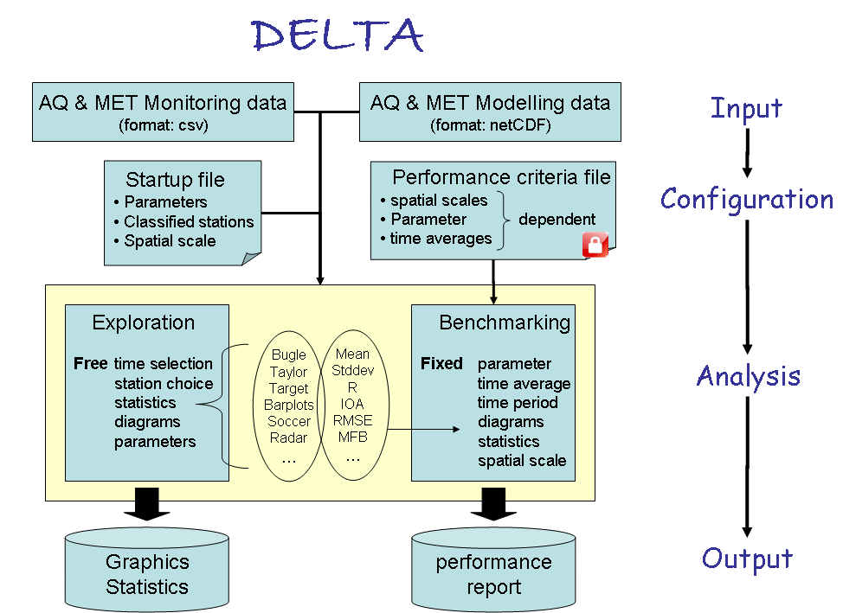

Figure . Structure of the DELTA software

Within the analysis two main modes exist: exploration and benchmarking mode. They are described in the next sections.

### Exploration

This mode allows the user to analyse different statistical metrics and diagrams, using various time intervals, various stations, various parameters (meteorological variables or pollutants) from one or more models. Different types of analysis can be performed:

* Temporal analysis can be performed with different options (running averages, daily min/max/mean, selection of seasons, week days/ week-end, and daylight/ night time hours.
* Spatial analysis can be performed in two ways: (1) indirectly: based on the classification of the monitoring stations in different geographical entities (different colors are then used for each defined geographical entity) or (2) directly: by using the Google Earth (or GeoMap) option, a functionality which permits to visualise a statistical parameter at each station as a point on a 2D map
* Multidimensional analysis can be performed. Dimensions here refer to monitoring parameters, models, scenarios and stations. One or more elements for each of those dimensions can be chosen and overlaid on a single diagram.

### Benchmarking

This mode allows to produce summary reports containing performance criteria for different statistical indicators related to a given model application in the frame of the AQD. The reports are obtained through an automatic procedure and follow a pre-defined template structured around core indicators and diagrams (see Concepts Section 5). Some bounds for specific statistical indicators (performance criteria and model quality objective) are included, aiming to help in the assessment of the model performance.

Contrary to the exploration mode described above, the freedom left to the user in benchmarking mode is minimal, i.e. DELTA automatically produces the performance report.

The template for reporting model performances is application specific (assessment or planning). In the current prototype version only assessment templates are considered and have been prepared for O3, NO2 and PM10. In terms of diagrams and indicators, the template is independent of spatial scale and pollutant but performance criteria and model quality objectives (see next Section) can be pollutant and/or scale specific. Note that specific templates are proposed for models delivering annual averages only.

## Model Quality Objective and Performance criteria

The main statistical indicators referred to in the follow-up analysis are:

|  |  |
| --- | --- |
| *Mean Bias* |  |
| *Root Mean Square Error* |  |
| *Correlation Coefficient* |  |
| *Centred Root Mean Square error* |  |
| *Normalised mean standard deviation* |  |

Table : List of the main statistical indices related to the MQO

### Model Quality Objective (MQO)

As described in METHOD2012 and UNCERT2012 the Model Quality Objective (MQO) used to test model results for a given application is defined as:

|  |  |  |
| --- | --- | --- |
|  |  | (1) |

where RMSU is the quadratic mean of the expanded measurement uncertainty U. With this formulation for the MQO the error between observed and modelled values (numerator) is compared to the absolute measured uncertainty (denominator).

* + - 1. MQO ≤ 0.5. In this case the RMSE between observed and modeled values is less than the observation uncertainty. Model results are in average within the range of the observation uncertainty for that station and it is meaningless to further improve model performances.
      2. 0.5 < MQO ≤ 1. In this case the RMSE between observed and modeled values is in average larger than the range of observation uncertainty but the model still is in the fulfillment zone.
      3. MQO > 1. In this case differences between observations and model results become significant and the model is not fulfilling the criteria.

This approach is flexible as it allows introducing more detailed information on observation uncertainty as they become available. Such an analysis is proposed in UNCERT2012 and is briefly summarized in Concepts Section 4.4 below. Note also that the MQO threshold remains always unity regardless of the pollutant or scale considered. Details on these interpretations are available in METHOD2012.

For annual average values, the MQO expressed in (1) reduces to

 (2)

### Performance criteria for Bias, R and SD

As described in METHOD2012 the equation relating some statistical indicators among themselves:

 (3)

can be used to derive performance criteria for 3 other indicators: R, NMB NMSD as follows:

|  |  |  |
| --- | --- | --- |
| **Indicator** | **Performance criteria** | **Reference** |
| Bias |  | (4) |
| Correlation |  | (5) |
| Standard deviation |  | (6) |

Table : Model performance criteria for Bias, Correlation and standard deviation

It is important to note that the performance criteria for R, NMB and NMSD do **not** represent **sufficient conditions** to ensure that the MQO is fulfilled. They are used here to indicate which aspects of the modeling application need to be improved. Indicative values for these indicators as a function of geographic area or station type are provided in METHOD2012.

Since the performance criteria for R, NMSD and NMB are station and time dependent (through σO and the mean concentration), normalized criteria can also be defined from Equation (4), (5) and (6) as follows:

|  |  |  |
| --- | --- | --- |
| **Indicator** | **Performance criteria** | **Reference** |
| Bias |  | (7) |
| Correlation |  | (8) |
| Standard deviation |  | (9) |

Table : Normalized model performance criteria for Bias, Correlation and standard deviation

One of the main advantages of this approach is to provide a selection of statistical indicators with a consistent set of performance criteria based on one single input: the measurement uncertainty U. The main RMSE-based performance criteria (i.e. the MQO) provides a general overview of the model performances while the associated Performance criteria for correlation, standard deviation and Bias can be used to highlight which of the model performances aspects need to be improved.

In previous DELTA versions (up to 3.4) only conditions (7), (8) and (9) have been used for visualization purposes. From version 3.5 onwards we differentiate different zones based on the following criteria:

|  |  |  |  |  |  |
| --- | --- | --- | --- | --- | --- |
| **Zone** | **Bias** | **Standard deviation** | **Correlation** | **MQO** | **Ref** |
| 1 |  |  |  |  | (10) |
| 2 |  |  |  |  | (11) |
| 3 |  |  |  |  | (12) |

Table : Criteria used to differentiate the different zones (orange, green and dashed lines limits) in the MQO and MPC diagrams

Zone 1: This is the fulfillment zone (green in diagrams). For the bias, correlation and standard deviation the criteria is calculated by assuming a perfect behavior for the two other statistical indexes (e.g. the criteria for bias is built on the assumption that R=1 and). For yearly averaged values the bias criteria becomes the MQO.

Zone 2: This zone (orange in diagrams) is built from Equation (11) and checks which of the three error types is dominating (i.e. which term in Equation (3) could be larger than 0.5).

This zone still indicates fulfillment of the MQO but the error is dominated by this particular indicator.

Zone 3: The error between modeled and observed values lies within the measurement uncertainty range. This zone is indicated by a dashed line within the green shaded area



### Performance criteria for high percentile values

The model quality objective described above provides insight on the quality of the model average performances but does not inform on the model capability to reproduce extreme events (e.g. exceedances). For this purpose a specific MQO indicator is proposed as:

 (13)

where “perc” is a selected percentile value and Mperc and Operc are the modelled and observed values corresponding to the selected percentile. The denominator is directly given as a function of the measurement uncertainty characterizing the Operc value. The default percentile value is currently set to 95% excepted for hourly NO2 which is automatically set to 99.8% (19th occurrence in 8760 hours), for the 8h daily maximum O3 set to 92.9% (26th occurrence in 365 days) and for daily PM10 and PM25 both set to 90.1% (36th occurrence in 365 days). Note that this indicator is only used in the [summary report](#_Summary_Report_(Fig.2).

### An expression for the measurement uncertainty

In equation (1), (2) and (13) the observation uncertainty (normalization factor) appears either as a quadratic mean RMSU, U($\overline{O}$) or Uperc, respectively. The derivation of these uncertainty expressions, allowing for a simple implementation and calculation in DELTA is detailed in UNCERT2012 and only the final formulations are provided here. The uncertainty of a single observation value is expressed as:

 (14)

Where:

* $u_{r}^{RV}$ represents the estimated relative measurement uncertainty around a reference value (RV) for a reference time averaging, e.g. the daily/hourly Limit Values of the AQD.
* α is the fraction of the uncertainty around the reference value (RV) which is non-proportional to the concentration level.
* k is the coverage factor. Each value of k gives a particular confidence level that the true value lies within the interval of confidence consisting in Oi ± U. Most commonly, the expanded uncertainty is scaled by using the coverage factor k = 2, to give a level of confidence of approximately 95 percents. Levels of confidence of 90% and 99% would lead to coverage factors around k=1.40 and k=2.6, respectively. More details are provided in Section 4.6 regarding the link between the confidence levels associated to the measurements and model results on one hand and the confidence level associated to the model-to-measure differences as used in the MQO (see Eq. 1).

From Equation (14) it is possible to derive an expression for RMSU as:

 (15)

where is the standard deviation of the measured time series.

For model producing annual averages, the uncertainty is expressed as:

 (16)

where Np and Nnp are used for annual averages only and account for the compensation of errors (and therefore a smaller uncertainty) due to random noise and other factors like periodic re-calibration of the instruments. As seen in equation (16) the standard deviation term is assumed to be linearly related to the observed mean value in the annual average formulation. The calculation of the Np coefficient accounts for the correction resulting from this assumption (see Method 2012 and UNCERT2012 (working document) for more details).

For the percentile uncertainty used in equation ( (13), equation (14) is used with O=Operc.



The following values are currently proposed (UNCERT2012). Note that the value of alpha for PM2.5 referred to in the UNCERT2012 – working note has been arbitrarily modified from 0.018 to 0.050 to avoid larger uncertainties for PM10 than PM2.5 in the lowest range of concentrations.

|  |  |  |  |  |  |  |
| --- | --- | --- | --- | --- | --- | --- |
|  | k | $$u_{r}^{RV}$$ | RV | α | Np | Nnp |
| NO2 | 2.00 | 0.120 | 200 ug/m3 | 0.040 | 5.2 | 5.5 |
| O3 | 1.40 | 0.090 | 120 ug/m3 | 0.620 | NA | NA |
| PM10 | 2.00 | 0.140 | 50 ug/m3 | 0.018 | 40 | 1 |
| PM25 | 2.00 | 0.180 | 25 ug/m3 | 0.05 | 40 | 1 |
| WS (test) | 2.00 | 0.130 | 5 m/s | 0.800 | NA | NA |
| TEMP (test) | 2.00 | 0.025 | 25 K | 1.000 | NA | NA |

Table : List of the parameters used to calculate the uncertainty (see formulas (15) and (16))

The values reported in this table can be used to produce uncertainty curves for each compound (see figures below). Parameters for other species than those mentioned in the above table can be implemented easily in DELTA (see next Concepts Section 6.1 for more details)

|  |  |
| --- | --- |
| Figure : Relative uncertainties for daily averaged PM10 and PM2.5, hourly NO2 and 8h daily maximum O3 as a function of concentration. | Figure : Absolute uncertainties for daily PM10 and PM2.5, hourly NO2 and 8h daily maximum O3 as a function of the concentration. |
| Figure : Absolute uncertainties for hourly wind speed and temperature. | Figure : Relative uncertainties for yearly PM10, PM2.5 and NO2 as a function of the concentration. |
| Figure : Absolute uncertainties for yearly PM10, PM2.5 and NO2 as a function of the concentration level. | Figure : Comparison of daily averaged PM10 uncertainty for a single value and for an entire time series. [comparison of formulations (14) referred to as (O) in figure) and (15) referred to as (O and SD) in figure)] |

In Figure 7 we compare formulations (14) and (15) for a single value and a time series respectively. For visualisation purposes we assume that a linear relationship holds between the squared mean and the sum of the squared mean and variance of the observations, i.e. . Based on 2009 observations, the following values of have been used (0.3 for NO2, 0.6 for PM10 and PM2.5 and 0.1 for O3). Note that this linear simplification is done for visualization purposes only whereas the full formulation (Eq. 15) is implemented in DELTA.

### An alternative formulation for the observation uncertainty

The uncertainty formulation (14) requires two parameters to be defined: the proportionality coefficient and the relative expanded uncertainty, around an arbitrarily fixed reference concentration (RV). Because the first of these two parameters is not always straightforward to establish, we propose here an alternative formulation.

Equation (14) can be re-written as a linear relationship between the squared uncertainty (U2) and the squared concentration (O2):



But this linear relationship can also be simply expressed as:



where L is a low range concentration value (i..e close to zero) and UL its associated absolute expanded uncertainty. Comparing the two formulations we get:



The two above relations (17) and (18) allow switching easily from one formulation to the other. The first formulation requires defining values for both and , around an arbitrarily fixed reference value (RV), while the second formulation requires defining uncertainties around two arbitrarily fixed concentrations (RV and L). An equivalent to Table 5 for the second methodology is provided below with L=0.

|  |  |  |  |  |  |
| --- | --- | --- | --- | --- | --- |
|  | RV | $$U^{RV}$$ | $$U^{0}$$ | Np | Nnp |
| NO2 | 200 ug/m3 | 48 ug/m3 | 9.6 ug/m3 | 5.2 | 5.5 |
| O3 | 120 ug/m3 | 15.1 ug/m3 | 11.9 ug/m3 | NA | NA |
| PM10 | 50 ug/m3 | 14 ug/m3 | 1.87 ug/m3 | 40 | 1 |
| PM25 | 25 ug/m3 | 9 ug/m3 | 2.01 ug/m3 | 40 | 1 |
| WS (test) | 5 m/s | 1.3 m/s | 1.16 m/s | NA | NA |
| TEMP (test) | 25 K | 1.25 K | 1.25 K | NA | NA |

A practical example of introduction of the uncertainty parameters using the second methodology is provided in User’s Guide section 6.1

### The 90% principle

For all statistical indicators used in DELTA for benchmarking purposes the approach currently used in the AQD has been followed. This means that the model quality objective must be fulfilled for at least 90% of the available stations. Given the integer nature of the station number this criteria sometimes means a larger than 90% of the available stations to fulfil the criteria. For example all stations will need to fulfil the criteria if the number of stations is lower than 10. This point is also relevant when considering group of stations (see User’s Guide Section 5.1) when the 90% option is selected; the number of stations which can be discarded and the effective percentage of stations kept within a given group depends on the number of stations composing this group.

## Benchmarking report

These reports are currently available for the hourly NO2, the 8h daily maximum O3 and daily PM10 and PM2.5.

### Hourly frequency

#### *Target Diagram (Fig9 Upper diagram)*

The MQO as described by Equation (1) is used as main indicator. In the normalised Target diagram, it represents the distance between the origin and a given station point. As mentioned above the performance criterion for the target indicator is set to unity (circle limit) regardless of spatial scale and pollutant and it is expected to be **fulfilled by at least 90%** of the available stations. The normalised bias (first term on the right hand side of Equation [3]) is use for the vertical axis while the centred root mean square error (CRMSE) (sum of the two last terms on the right hand side of Equation [3]) ius used to define the X axis.

The percentage of stations fulfilling the target criterion is indicated in the upper left corner and is meant to be used as the main indicator in the benchmarking procedure. As mentioned above, values higher than 90% must be reached. The uncertainty parameters () used to produce the diagram are listed on the top right-hand side.

The four quadrants in the Target diagram correspond to the following conditions, all based on Equation (3):

|  |  |  |
| --- | --- | --- |
| Condition I | Condition II | Position in target diagram |
|  |  | Top quadrant |
|  |  | Bottom quadrant |
|  |  | Right quadrant |
|  |  | Left quadrant |

The equation used to distinguish the right (SD) from the left quadrants (R) (condition II) can be rewritten as:



Or in graphical terms:

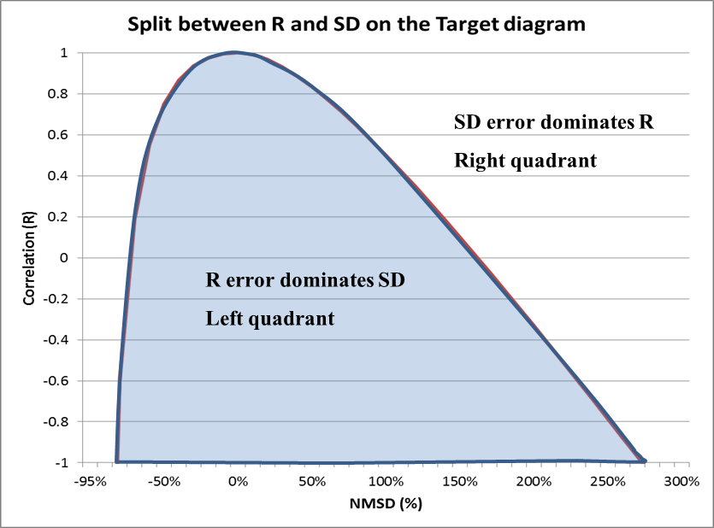

Figure : Split between R- and SD-dominated errors in the Target diagram. (R,SD) indices couples falling in the blue shaded area will be located on the left quadrant, others on the right quadrant.

It is straightforward from this diagram to identify which couples of SD and R indices will lead the station to be within the left or right quadrants

In addition the Target diagram also allows distinguishing easily the performances for single stations or group of stations (e.g. different geographical regions in this example) by the use of different symbols and/or colours.

More details on this adapted Target diagram can be found in METHOD2012.

#### *Summary Report (Fig.9 Lower diagram)*

The summary statistics table provides information on model performances. It is meant as a **complementary** source of information to the MQO (upper diagram) to identify model strengths and weaknesses. The summary report is structured as follows:

* ROWS 1-2 (OBS) provide the measured observed means and number of exceedances for the selected stations. In benchmarking mode, the threshold values for calculating the exceedances are set automatically to 50, 120 and 200 for the daily PM10, the hourly NO2 and the 8h daily O3 maximum, respectively. For other variables (PM25, WS…) for which no threshold exists, the value is set to 1000 so that no exceedance will be shown.
* ROWS 3-6 (TIME) provide an overview of the temporal statistics for bias, correlation and standard deviation as well as information on the ability of the model to capture the highest range of concentration values. Each point represents a specific station. Values for these four parameters are estimated via equations (7), (8), (9) and (13) respectively. The green shaded area represents criteria fulfilment. The orange shaded area (for the three first indicators) represents fulfilment but the error associated to the particular statistical indicator is dominant (see Concepts Section 4.2 and Table 4 in particular for more details). **Note again that fulfilment of the bias, correlation, standard deviation and high percentile related indicators does not guarantee that the overall MQO based on RMSE is fulfilled.**
* ROWS 7-8 (SPACE) provide an overview of spatial statistics for correlation and standard deviation. Average values over the selected time period are first calculated for each station and these values are then used to compute the spatial correlation and standard deviation. Fulfilment of the performance criteria (8) and (9) is then checked for these values. As a result only one point representing the spatial correlation of all selected stations is plotted. Colour shading follows the same rules as for rows 3-5.

Note that for indicators in rows 3 to 8, values beyond the proposed scale will be represented by the station symbol being plotted in the middle of the dashed zone on the right/left side of the proposed scale

For all indicators, the third column provides information on the number of stations fulfilling the performance criteria (green beyond 90% of the stations fulfilling, red below 90%).

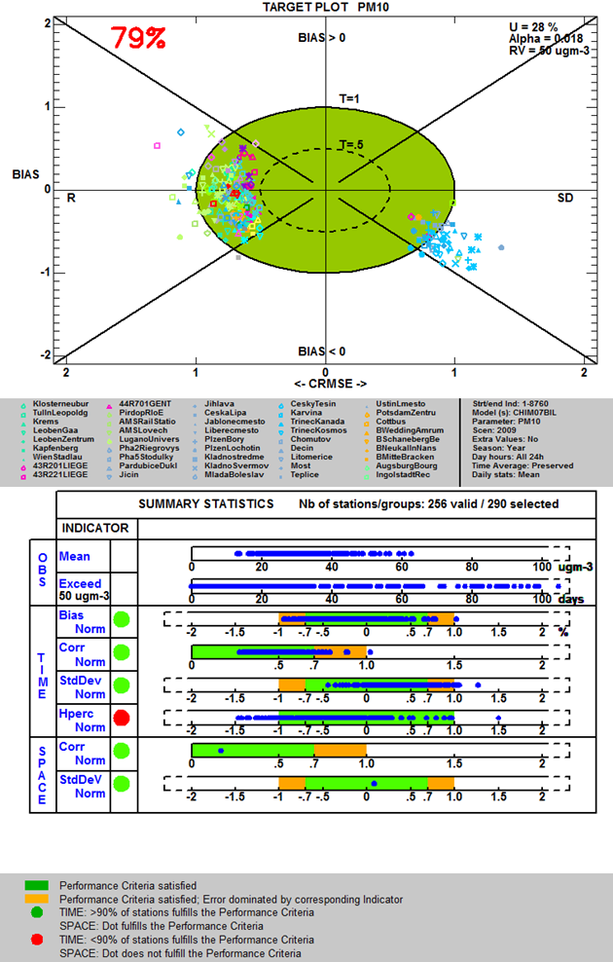

Figure : Example of benchmarking performance summary report

### Yearly frequency

#### *Scatter Diagram (Fig.10 Upper diagram)*

The MQO described in Concepts Section 4.1 for yearly averaged results (i.e. based on the bias) is used as main indicator. In the scatter plot, it is used to represent the distance from the 1:1 line. As mentioned above it is expected to be fulfilled by at least 90% of the available stations. The uncertainty parameters () used to produce the diagram are listed on the top right-hand side

The Scatter diagram also provides information on performances for single stations or group of stations (e.g. different geographical regions in this example below) by the use of symbols and colours.

More details on the scatter diagram and possible options can be found in METHOD2012.

#### *Summary Report* *(Fig.10 Lower diagram)*

The summary statistics table provides information on model performances. It is meant as a **complementary** source of information to the bias-based MQO to identify model strengths and weaknesses. It is structured as follows:

* ROW 1 (OBS) provides the measured observed means for the selected stations.
* ROW 2 (TIME) provides information on the fulfilment of the bias-based MQO for each selected stations. Note that this information is redundant with the scatter diagram but kept if the summary report is used independently from the scatter diagram.
* ROWS 3-4 (SPACE) provide an overview of spatial statistics for correlation and standard deviation. Annual values are used to calculate the spatial correlation and standard deviation. Criteria (8) and (9) are here used to check fulfilment of the performance criteria. The same explanation for the green and orange shaded areas as for the hourly report holds.

Note that for indicators in rows 2 to 4, values beyond the proposed scale will be represented by the station symbol being plotted in the middle of the dashed zone on the right/left side of the proposed scale

The third column provides information on the number of stations fulfilling the performance criteria, Green beyond 90% of the stations fulfilling and red below.

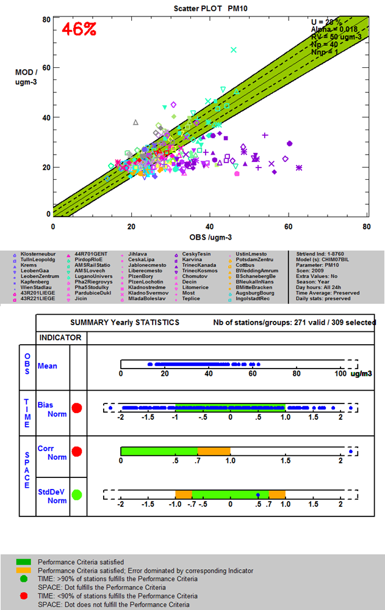

Figure : Example of benchmarking performance summary report

## References

Cuvelier C., P. Thunis, R. Vautard, M. Amann, B. Bessagnet, M. Bedogni, R. Berkowicz, J. Brandt, F. Brocheton, P. Builtjes, C. Carnavale, A. Coppalle, B. Denby, J. Douros, A. Graf, O. Hellmuth, A. Hodzic, C. Honoré, J. Jonson, A. Kerschbaumer, et al., 2007: CityDelta: A model intercomparison study to explore the impact of emission reductions in European cities in 2010. Atmospheric Environment, Volume 41, Issue 1, Pages 189-207

Thunis P., L. Rouil, C. Cuvelier, R. Stern, A. Kerschbaumer, B. Bessagnet, M. Schaap, P. Builtjes, L. Tarrason, J. Douros, N. Moussiopoulos, G. Pirovano, M. Bedogni, 2007, Analysis of model responses to emission-reduction scenarios within the CityDelta project, Atmospheric Environment, Volume 41, Issue 1, January 2007, Pages 208-220

Thunis P., E. Georgieva, S. Galmarini, 2010: A procedure for air quality models benchmarking. (<http://fairmode.ew.eea.europa.eu/fol568175/work-groups>)

P. Thunis, A. Pederzoli, D. Pernigotti, 2010: Performance criteria to evaluate air quality modeling applications, Atmospheric Environment, Volume 59, November 2012, Pages 476-482

Thunis P., D. Pernigotti and M. Gerboles, 2012: Model quality objectives based on measurement uncertainty: Part 1: Ozone. 2012 Atmospheric Environment, Volume 79, November 2013, Pages 861-868

Pernigotti D., P. Thunis, M. Gerboles and C. Belis.2012. Model quality objectives based on measurement uncertainty: Part II: PM10 and NO2. Atmospheric Environment, Volume 79, November 2013, Pages 869-878

Part II

# User’s Guide

## What’s new

### From version 4.0 to 5.0

* An installer is now provided for DELTA under Windows environment. No prior installation of the IDL virtual machine is any more requested. A demo dataset is provided within this installer. See installation instruction in the next section.
* A Linux version is available for download. See installation instruction in the next section.
* The utility function “Data-Check Integrity Tool” is automatically run by default with new datasets to check the consistency of the input data files. This run is performed once only.
* Monitoring data in “csv” format will be automatically converted into “netcdf” format at first use to save time in future applications.
* Modelling data entered in “csv” format will automatically be converted in “netcdf” format at first use.
* Percentiles value for O3 and PM10/PM2.5 used to calculate the high percentile indicator included in the summary report have been set to correct values (from 90.4 to 92.9% for O3 and from 93.1 to 90.1% for PM2.5 and PM10). Values have been corrected in the first part of this guide accordingly.
* Paths to existing applications (Word, Excel, Google Earth…) need to be set in the init.ini file in the resource directory. This operation can now be done automatically through the “Find external application paths” in the help menu. Note that this operation requires a substantial amount of time but will be performed once only.
* The design of the postscript Benchmarking report has been improved.
* Some minor bugs in the formula of Tables 2, 3 and 4 in the first Section have been corrected.
* For yearly models:
  + The mouse recognize functionality has been re-activated for the summary report (bug fix)
  + Monitoring data can be formatted in one single “csv” file

### From version 3.4 to 4.0

* Inclusion of a new diagram “geomap” for hourly/daily model results.
* The X-axis of the [target diagram](#_Target_Diagram_(Fig9) is positive in both directions.
* Uncertainty parameters are now indicated on the [target diagram](#_Target_Diagram_(Fig9) and on the scatter diagram
* Addition of new MQO for PM2.5, WS and TEMP. Parameters for the PM2.5 MQO have been revised to avoid uncertainties smaller than PM10 in the lower concentrations range.
* Update of uncertainty parameters for NO2 and PM10 (yearly and hourly)
* Inclusion of the myDeltaInput option to facilitate the management of multiple datasets. Note that DELTA can run in absence of this new input file.
* Inclusion of MQO for SO4, NH4, NO3, EC and TOM for testing purposes. Uncertainty parameters are available in the “goalscriteria_oc.dat” configuration file.
* Correction of geomap SD and R error symbol types: switch to be consistent with Target.
* Correction of the counting of valid station in the yearly scatter diagram
* Modifications of the [hourly/daily summary report](#_Summary_Report_(Fig.2): the RDE indicator has been suppressed and substituted by a threshold indicator
* The bug in the summary report (calculation of the spatial correlation and spatial standard deviation – no point appearing) has been fixed.
* The legend of the [summary report](#_Summary_Report_(Fig.9) has been re-designed
* Modification of the [yearly summary report](#_Summary_Report_(Fig.3): RDE has been dropped.
* Correction of [Target diagram](#_TARGET_(8H_Max,): SD and R related errors were assigned the wrong side of the diagram (left vs. right)
* Uncertainty values for PM10 TEOM and beta-ray measurement techniques have been included in the “goalsandcriteria_oc” configuration file. See here for more details.
* Addition of a “save main statistical indices” option. This option runs automatically when the summary report diagram is selected. See here for more details.
* Correction: The generation of performance reports in pdf format did not work properly in version 3.6.
* The MQO for 3h average NO2 has been removed

## Installation and running steps

The current version of the Delta Tool is available for Windows and Linux environments.

**Installation and running steps under WINDOWS**

* Download and run the setup.exe file available on the Delta web page. This will create a “Delta Tool” icon on the desktop as well a “JRC_DELTA” menu in the Windows start menu (lower left icon on your desktop). You can launch the application by double-clicking on the icon.
* After the first installation the software is configured to operate with a demo dataset. If you wish to re-use data you produced with an earlier version of the software, please follow the below steps:
  + Access the $home$ directory through the JRC_DELTA menu.
  + Create a sub-directory under data/monitoring, e.g. “Mydata” (parallel to demo) and include in it your monitoring data.
  + Create a sub-directory under data/modeling, e.g. “Mydata” (parallel to demo) and include in it your modeling data
  + Include your startup.ini file and rename it into startup_MyData.ini in the resource sub-directory
  + Adapt the names and paths in the MyDeltaInput file (change demo into Mydata). The MyDeltaInput is placed on the resource subdirectory but is also accessible through the start menu.
  + Re-start the Delta application
* A “JRC-DELTA” program item in the start menu gives you access to 1) the home installation directory, 2) the MyDeltaInput configuration file, 3) the user’s guide and 4) the web-site.

**Installation and running steps under LINUX**

* Download and unzip the setup_linux.tar file available on the Delta web page in a new directory (e.g. DeltaTool). This will create a DeltaTool.exe as well as a sub-directory structure (resource, configuration, data...) You can then launch the application by running the DeltaTool executable.
* After the first installation the software is configured to operate with a demo dataset. If you wish to re-use data you produced with an earlier version of the software, please follow the below steps:
  + Create a sub-directory under data/monitoring, e.g. “Mydata” (parallel to demo) and include in it your monitoring data.
  + Create a sub-directory under data/modeling, e.g. “Mydata” (parallel to demo) and include in it your modeling data
  + Include your startup.ini file and rename it into startup_MyData.ini in the resource sub-directory
  + Adapt the names and paths in the MyDeltaInput file (change demo into Mydata). The MyDeltaInput is placed in the resource subdirectory.
  + Re-start the Delta application
  + Paths will need to be updated in the init.ini file (under the resource sub-directory) to allow some external applications to run (Word, pdf reader…).

The user’s guide is available in the help sub-directory

## Preparation of input files

In order to run the Tool, the following files have to be prepared by the user

* The configuration file <startup.ini>. This file is located in folder ...\resource. For handling different data (obs – mod) sets, see Users Guide Section 6.4
* Files with observed data (one file for each monitoring station). These files should be in ”csv” or “cdf” format and be placed in folder ...\data\monitoring
* Files with modeled data at the locations of the stations (one file per model and scenario). Such files should be in “csv” or “cdf” format. If only “csv” files are available, DELTA will automatically create a “cdf” version at first use. Each .cdf file may contain model results for several locations (stations). The .cdf files should be placed in folder ...\data\modeling. If results from more than one model are used, the utility to create cdf files from csv files should be used (available from help menu, see Section 9.2).
* The file “MyDeltaInput” in the resource directory should then be adapted to the paths and file names selected by the user.

### Init.ini

The resource folder contains an ASCII file named *init.ini* where specific software (WORD, ADOBE...) location information should be provided. The user should modify the paths according to his personal installation settings. This is needed, e.g, to be able to use the help in the Delta Tool. The right hand side of the following lines (end of the *init.ini* file) should be adapted. This updating operation can be done manually or automatically through the help menu (Find external application paths). **Note that this operation might require a substantial amount of time but will be performed once only on a given computer**.

BROWSER_LOCATION=C:\Program Files\Mozilla Firefox\firefox.exe

WORKSHEET_LOCATION=C:\Program Files\Microsoft Office\OFFICE11\EXCEL.EXE

DOCUMENTSREADER_LOCATION=C:\Program Files\Microsoft Office\OFFICE11\WINWORD.EXE

NOTEPAD_LOCATION=notepad.exe

PDFREADER_LOCATION=C:\Program Files\Adobe\Acrobat 7.0\Acrobat\Acrobat.exe

GOOGLEEARTH_LOCATION=C:\Program Files\Google\Google Earth\client\googleearth.exe

### Startup.ini

The configuration file (startup.ini) is common to both inputs with hourly and yearly frequencies. It is located in ...\resource. The file is in ASCII format and contains some general information about the spatial scale, the parameters selected for evaluation and the characteristics of the monitoring stations. The file has three main sections:

* MODEL – includes information about the year, spatial scale and input frequency.
* PARAMETERS - includes variable names and measurement units
* MONITORING – includes list of all stations with their siting characteristics and parameters measured.

The following conventions apply:

* Each blank row or each line beginning with "[", ";" or "#" will be discarded
* No blanks between fields are permitted
* Line breaks are not allowed.
* The three section headers: “[MODEL]”, “[PARAMETERS]” and “[MONITORING]” are compulsory,
* Station codes and abbreviation codes must be unique.
* The station names should not include blanks and special characters such as “.”,” ’ ”, “;”,”-“
* Only the symbol “_” is allowed.
* Variables must be separated by an asterisk.
* The station names must be EXACTLY (including case sensitivity) the same used in the observation data files and modeled data files.

**Example:**

[MODEL]

;Year

;frequency

;Scale

2009

hour

urban

[PARAMETERS]

;Species;type;measure unit

SO2;POL;gm-3

NO2;POL; gm-3

PM25;POL; gm-3

PM10;POL; gm-3

WS;MET; m/s

TEMP;MET; C

[MONITORING]

Stat_Code;Stat_Name;Stat_Abbreviation;Altitude;Lon;Lat;GMTlag;Region;Stat_Type;Area_Type;Siting; listOfvariables

IT00000;station0;STAT0;681.;8.931;44.31;GMT+1;Lombardia;Background;Urban;Plane;TEMP*PM10*O3;

IT00001;station1;STAT1;962.;10.03;44.97;GMT+1;Veneto;Traffic;SubUrban;Hilly;TEMP*O3;

IT00002;station2;STAT2;851.;11.34;44.18;GMT+1;Piemonte;traffic;urban;Mountain;WS*PM10*O3*SO2;

IT00003;station3;STAT3;806.;7.597;46.02;GMT+1;Emilia-Romagna;Industrial;Rural;Valley;WS;

IT00004;station4;STAT4;769.;8.222;44.29;GMT+1;Lombardia;Background;Urban;Plane;TEMP*O3;

IT00005;station5;STAT5;163.;9.193;45.85;GMT+1;Friuli Venezia Giulia;Unknown;Unknown;Coastal;PM10;

...

<EOF>

**Description:**

[MODEL] section:

The first three lines are just comments

* *Year*: year of interest
* *Frequency* (lowercase): Either hour or year. This parameter should be set to “hour” for models delivering outputs with an hourly or daily frequency and set to “year’ for models delivering outputs as annual averages (see User’s Guide Section 3.5).
* *Scale* (lowercase): Either local (traffic), urban or regional. But not used currently

[PARAMETERS] section:

The first line is a comment which gives a hint of the contents of the following lines:

* *Species*: name of the variable (lower or upper case but should be consistent with observation and modeling files)
* *Type*: “POL” and “MET” indicate air quality and meteorological variables respectively. These categories are created to facilitate filtering during the selection phase and can be defined by the user at his convenience.
* *Measure units*: the units MUST be μgm-3 for concentrations. For the other variables, see the notes below.

Notes:

* Each line contains the name of a parameter, the type and the measurement unit, separated by semicolons. The parameters are those available in the observation dataset. It is permitted to have lines with parameters not present in the dataset. The sequence of parameters is irrelevant.
* Some parameter names and units are pre-assigned and should be obligatory followed (since they are used in the benchmarking procedure): O3 [μgm-3], NO2 [μgm-3], PM10 [μgm-3], WS [ms-1] (wind speed), TEMP [degC] - temperature, SH [g/kg] (specific humidity)

[MONITORING] section

The first row contains the labels. The labels currently referred to as: region, station type, area type and siting can be modified by the user and will appear as modified in the data selection window. Each subsequent row refers to a given station, where:

* Stat_Code: national identification of the station e.g. AT0001ST, or VEN00356, or user’s assigned code (e.g. STAT001)
* Stat_Name (case sensitive): combination of letters and/or numbers ; only the symbol “_” is allowed blanks and special characters are not allowed
* Stat_Abbreviation: station name abbreviation (4 letters). The abbreviation will be the one identifying the station on the DELTA output graphs and statistics
* Altitude: height above sea level (in meters)
* Lon, Lat: Longitude and Latitude (in decimal degrees)
* GMTlag: Time zone (currently not used)
* Region: Name of the administrative region to which the station belongs. In alternative – a user defined region (Naming rules similar to “Stat_Name”)
* Stat_Type: background, traffic, industrial
* Area_Type: urban, suburban, rural
* Siting: Categories are proposed: mountain, hilly, plane, valley or coastal. They will be used eventually to group stations and calculate average statistics for each group; If other categories suit better user’s stations, they can be defined here.
* listOfvariables..: The variables measured at each station , (PM10, O3, WS etc). The variables are separated by an asterisk.

**Note**: It is left to the user to assign appropriate fields to classify stations. In our example, REGION, STAT_type, Area_Type and Siting are selected but other choices could have been made. These choices will configure the widget menus to help with the selection of stations according to the chosen fields.

### Observation file

### Hourly Frequency

Monitoring stations to be used with the Tool may have either air quality data, either meteorological data or both.

**csv format**

***Files names and type:***

* Each station must have an associated file containing the data in comma separated format and with extension .csv, e.g. “**station1.csv”**
* The file names should be consistent (including case sensitivity) with the naming rules used in the configuration file (startup.ini).

***Files location:***

….\data\monitoring

***Files structure:***

The first row must contain the labels of the columns: year (4 digits), month (1-12), hour (0-23) and the names of the observed parameters at each station. Following lines should include the observed values on an hourly basis (8760 rows (or 8784 for leap year) if entire year is available). If for a given hour data are missing for all parameters, the line can be omitted. Data are recognized by their associated date and time.

**Example: filename <station1.csv>**

year;month;day;hour;O3;PM10;WS;WD;TEMP;

2005;1;1;0;40.1;55.4;0.75;310;15.6;

2005;1;1;1; 40.1;55.4;0.75;310;15.6;

2005;1;1;2; 40.1;55.4;0.75;310;15.6;

…

2005;12;31;23; 40.1;55.4;0.75;310;15.6;

<EOF>

**Particular requirements:**

* The station names used in startup.ini must be used for each one of these files.
* For non-annual average values each file must contain observation values on an hourly basis. For leap years, data for February 29th may be included in the files.
* Data will be read by dates. Missing dates (i.e. lines) will automatically be treated by DELTA as -999.
* If data are monitored on a daily basis (e.g PM10), please put the daily value at all hours from 0 to 23 for this day.

Remark: Daily deposition observations (for example rain) should be distributed over the 24 hours of the particular day.

* If both air quality and meteorological measurements are available for the same site, the data must be included in the same file (as in the example above)
* Each blank row or beginning with "[", ";" or "#" will be discarded
* Spaces are not permitted between the fields.
* Line breaks are not allowed.
* The semi-column ending each lines is not mandatory

**cdf format**

The “cdf” format is identical to the one specified for modeling result data (option 2). If provided as “csv”, the conversion from to “cdf” will be performed automatically when running DELTA.

### Yearly Frequency

**Option 1: Each station monitoring data is assigned a specific file**

***Files names and type:***

* Each station must have an associated file containing the data in comma separated format and with extension .csv, e.g. “**station1.csv”**
* The file names should be consistent with the naming rules used in the configuration file <startup.ini> (see Section 3.2).

***Files location:***

….\data\monitoring

***Files structure:***

The first row must start with the label “YearlyAvg” to indicate that yearly averaged results are used. Should follow the year (4 digits) and species of interest. All fields should be separated by semi-column. Row 2 should contain the numeric observed values for the parameters mentioned in row 1.

**Example: filename <station1.csv>**

YearlyAvg;2009;PM10;NO2;WS

; parameter1;parameter2;parameter3

55.1;15.6; 2.1

<EOF>

**Particular requirements:**

* The station names used in startup.ini must be used for each one of these files.
* If data are missing the gaps should be filled by -999.
* If both air quality and meteorological measurements are available for the same site, the data must be included in the same file (as in the example above)
* Each blank row or beginning with "[", ";" or "#" will be discarded
* Spaces are not permitted between the fields.
* Line breaks are not allowed.

**Option 2: All station monitoring data are assigned to a single file**

This “csv” format should be identical to the one specified for yearly modeling result data

### Model file

### Hourly Frequency

Modeled data can be prepared in one of the following formats:

* netcdf (option 1) format (one single file for a given model and time period. A ncdf-variable must be generated for each station/species combination
* netcdf (option 2) format (one single file for a given model and time period. A ncdf-variable must be generated for each station.
* csv format (similar to the one described for the observations) Such files can then be converted to “cdf” format through the utility functionality available under the help menu.

**Description of the netcdf (option 1) format**

* One single netcdf file should be provided for a given model. It must contain a time series for each station and variable listed in <startup.ini >.
* The names of the parameters should be the same as in the configuration file <startup.ini>.
* The units in the netcdf file should be the same as specified in startup.ini

***Files location:***

….\data\modeling

***Files structure:***

Each data block inside the netCDF file should be named as “StatName_Parameter” (see examples below) where “StatName” is the name of the station corresponding to the one set in the <startup.ini >, and “Parameter” refers to the modeled pollutants and meteorological variables, as indicated in the <startup.ini >

Each data block should contain either (a) 1 year of hourly data for each station and parameter (1dimensional array with 8760 [8784 for leap years] hourly data) or (b) a specific time period smaller than the entire year. In the latter case an additional attribute should be included in the netCDF file to set the initial starting time (in hours) as follows (global attributes: StartHour = 1320 indicating that the period of interest starts at hour=1320). Within the specific time period data should be continuous, i.e. include missing values as “-999”.

In the case of a leap year model results for February 29th should be included (or set to -999) if the period contains this day.

Modeled data at a given station may contain either air quality fields, meteorological fields or both.

**Example: <2008_WRFCHIM_TIME.cdf>**

netcdf 2008_WRFCHIM_TIME.cdf {

dimensions:

T = 8760 ;

variables:

float station0_CO2(T);

float station1_NO2(T);

float station1_WS(T);

float station1_WD(T);

float station2_CO2(T);

float station2_NO2(T);

float station2_WS(T);

float station2_WD(T);

}

**Example: <2008_WRFCHIM_TIME.cdf> with time period less than entire year**

netcdf 2008_WRFCHIM_TIME.cdf {

dimensions:

T = 744 ;

global attributes:

StartHour = 1320s ;

variables:

float station0_CO2(T);

float station1_NO2(T);

float station1_WS(T);

float station1_WD(T);

float station2_CO2(T);

float station2_NO2(T);

float station2_WS(T);

float station2_WD(T);

}

**Particular requirements:** If a parameter is entirely missing (i.e. not provided by the model) for a station, but the same parameter is present in the monitoring dataset for the same station, the user must include that parameter in the *.cdf file as an hourly series of “-999”.

**Description of the netcdf (option 2) format**

* One single netcdf file should be provided for a given model. For each station it must contain a time series for each variable listed in the <startup.ini> file.
* All parameters (i.e. variables, e.g. NO2, PM10...) should be defined in byte format in a systematic order defined in a global attribute.
* The names of the parameters should be the same as in the configuration file <startup.ini> (see Section 2.2).

***Files location:***

….\data\modeling

***Files structure:***

Each data block inside the netCDF file should be named as “StatName_Parameter” (see examples below) where “StatName” is the name of the station corresponding to the one set in the <startup.ini >

Each data block should contain either (a) 1 year of hourly data for each station and parameter (2 dimensional array with 8760 [or 8784 for leap years] hourly data). Or (b) a specific time period smaller than the entire year. In the latter case an additional attribute should be included in the netCDF file to set the initial starting time (in hours) as follows (global attributes: StartHour = 1320 indicating that the period of interest starts at hour=1320). Within the specific time period data should be continuous, i.e. include missing values as “-999”.

Modelled data at a given station may contain either air quality fields, meteorological fields or both.

**Example: <2008_CHIM_TIME.cdf>**

netcdf 2008_CHIM_TIME.cdf {

dimensions:

V = 3 ;

T = 8760 ;

variables:

float station0 (T,V);

float station1 (T,V);

float station2 (T,V);

// global attributes :

: Parameters = 78b, 79b, 50b, 32b, 80b, 77b, 49b, 48b, 32b, 79b, 51b ;

}

Here ‘78b, 79b, 50b, 32b, 80b, 77b, 49b, 48b, 32b, 79b, 51b’ is the byte format of ‘NO2 PM10 O3’.

**Example: <2008_CHIM_TIME.cdf> with given time period (less than entire year)**

netcdf 2008_CHIM_TIME.cdf {

dimensions:

V = 3 ;

T = 744 ;

global attributes:

StartHour = 1320s ;

variables:

float station0 (T,V);

float station1 (T,V);

float station2 (T,V);

// global attributes :

: Parameters = 78b, 79b, 50b, 32b, 80b, 77b, 49b, 48b, 32b, 79b, 51b ;

}

Here ‘78b, 79b, 50b, 32b, 80b, 77b, 49b, 48b, 32b, 79b, 51b’ is the byte format of ‘NO2 PM10 O3’.

**Particular requirements:** If a parameter is entirely missing (i.e. not provided by the model) for a station, but the same parameter is present in the monitoring dataset for the same station, the user must include that parameter in the *.cdf file as an hourly series of “-999”.

### Yearly Frequency

Modeled data should be prepared in ASCII (csv*)* format. One single file should be provided for a given model. It must contain annual average values for each station listed in <startup.ini>.

***File name:*** <YEAR_MODELNAME_TIME.csv>

***Files location:*** .\data\modeling

***Files structure:***

YearlyAvg;2009;O3;PM10...

;Station;ValueParam1;ValueParam2...

Illmitz;40.3;45.34

Pillers;78;54.54

...

### Using DELTA with yearly output

By default the input files are configured for hourly frequency models but for models delivering annual averages it is possible to tune all configuration files to keep only relevant diagrams and elaborations within the selection menus (e.g. all diagrams using correlation will be discarded). For doing this, go in your startup.ini file and set the frequency parameter to “year”.

## Delta Tool top menu

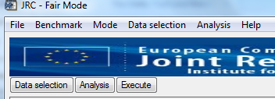

When starting Delta Tool the upper right-hand corner contains a menu that allows you, e.g. to run a Benchmark, and to save and retrieve selections you have made.

* **File**
  + Save image: Save main window diagram in various format (jpeg, tif...). Images are saved in the subdirectory “save”
  + BatchComposition: Allow the user to create his own batch composed of 1 to 4 different graphics
  + BatchSave: Save current elaboration as batch
  + BatchRestore: Restore batch from existing ones.
  + Exit
* **Benchmark** (see Section 4)
  + Assessment
    - daily 8h maximum O3
    - Daily averaged PM10
    - Daily averaged PM25
    - Hourly NO2
    - Hourly WS
    - Hourly Temperature
    - Yearly PM10
    - Yearly NO2
  + Planning (not available yet)
* **Mode**
  + Select mode (inactive)
  + Hide/Show Recognize Info: Mouse recognize window is turned on/off
* **Data selection**
  + Select data: Opens the “Data selection” window (similar to “data selection”).
  + Save data: Save current “data selection”
  + Restore data: Restore “data selection” from existing ones.
* **Analysis**
  + Select Analysis: Opens the “Analysis” window (similar to “Analysis”).
  + Save Analysis: Save current analysis choices.
  + Restore Analysis: Restore “analysis” from existing ones
* **Help**
  + Help file: Open the current DELTA version User’s guide (pdf format). The correct directory in which “adobe.exe” is located should be specified in the “init.ini” file in the “resource” directory (but this can be performed automatically – see option below).
  + Data check Integrity Tool: Open an independant window with the Check-IO processor to check consistency of the input data (see User’s Guide Section 9.1)
  + Delta WWW: Open the DELTA WWW homepage. The correct directory in which the browser executable is located should be specified in the “init.ini” file in the “resource” directory.
  + About: Version information
  + Find external application paths: Automatically update the paths to external applications (Word, Excel…). This operation might require a substantial amount of time but will only needs to be performed once.
  + Licence: End user licence agreement

## Exploration mode

In order to calculate a given statistical indicator and visualize it by a diagram the user has first to make selections in two interface windows – “data selection” and “analysis window” (activated through the starting window, see User’s Guide Section 5). The data selection and analysis interfaces are described in User’s Guide Sections 5.1 and 5.2 respectively. Finally the main DELTA graphical interface, which reflects the options previously selected by the user in the two interface windows, is described in User’s Guide Section 5.3.

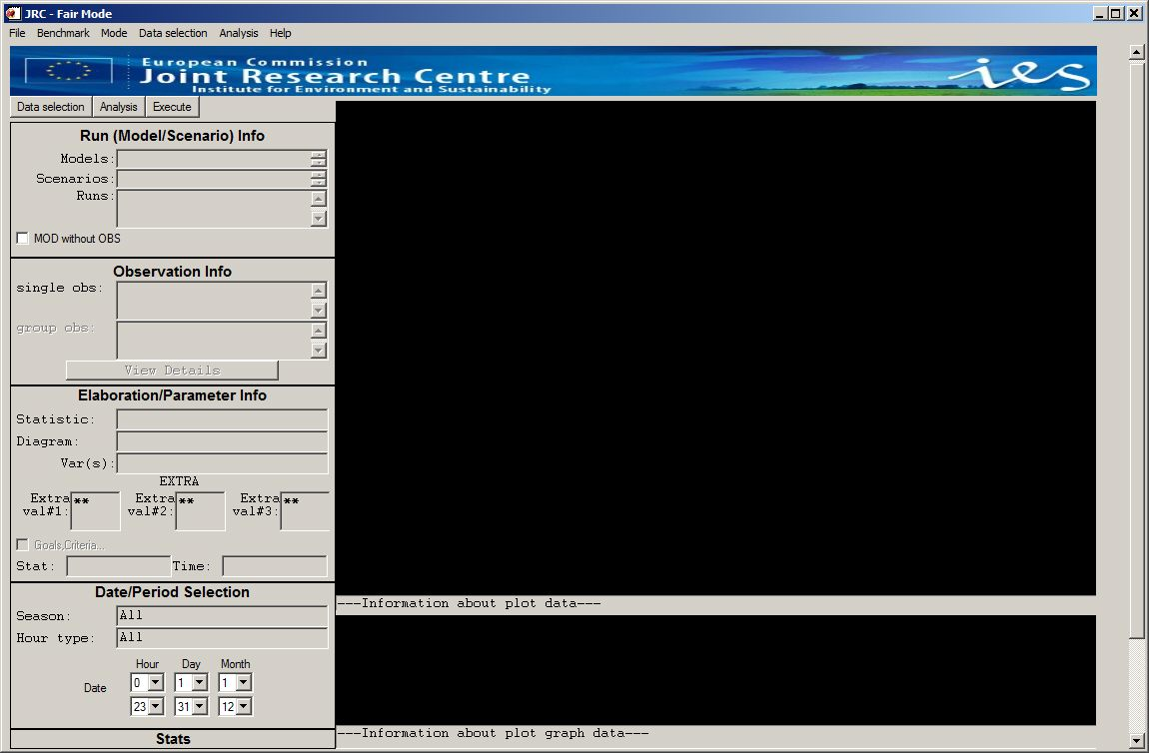

Figure The DELTA main interface (starting window)

### The data selection interface

A selection has to be made by the user in terms of

* a model/scenario (year) pair
* a parameter (e.g. NO2)
* a monitoring station

An example is given in Figure 12.

In brief, the selections are made in the following way:

* **Model selection**: In the left pane select one or more models + scenarios.
* **Parameter selection**: In the right pane first select Type, then Parameters (you may select several elements by Ctrl + Click).
* **Station selection:** The panels Region, Station Type, Area Type and Siting indicate some filters, which may help you in selection of stations. Apply relevant filters, so the panel Available becomes populated with some stations. Use Ctrl + Click on those you wish to select. Finally, click the Add button to make the selection effective.
* **Optionally save:** You may save the list of stations by clicking the ’Save Obs’ button (the ‘Load Obs’ button allows you to retrieve a previously saved list).

Some more details follow.

Various filters are available to facilitate the selection of the appropriate monitoring stations in terms of regions, types. These filters are defined in the configuration file <startup.ini>, where the user can make the station classification categories case specific.

Note: When a user selects a parameter (e.g. O3) in the "data selection" window, all stations measuring that parameter automatically appear in the "available" section. The user can then make his selection among these available stations and add them in the “selected” section. At this stage the user can still change his mind and select another parameter (e.g. PM10). The list of selected stations will be updated after warning the user.

The user has the possibility to save his choices and to reload them at a later time. Two modalities exist which can be useful to avoid repeating frequently used selections.

Modality (1): In order to save the selections in the data selection window, choose “save data” from the top “data selection” pop up menu. A new window appears with the request to put a file name. File extension must be *.elb. By default the file is saved in the dir…. \save.To reload the saved selections, -choose “restore data” from the top “data selection” pop up menu.

Modality (2): In order to save the station selection only, press the button ‘save obs’ in the lower right corner of the data selection window. A new window appears with the request to put a file name. File extension will be *.obl. By default the file is saved in the dir…. \save.To reload the saved selections, -press the button “Load Obs”.

A set of stations can either be treated as a number of single entities or as a group. In the case of groups the user will be asked to select between “mean” and “90% percentile” options. In the first case the mean of the stations statistical indicators will be represented as a single dot/symbol in the diagram whereas in the second option the worst statistical indicator among 90% of the available stations (rejecting 10%) is selected. **This latter choice must be used with diagrams in which performance criteria are present** and indicate whether this criterion is fulfilled for the selected group of stations.

MOD without OBS functionality”

Scenarios functionality:

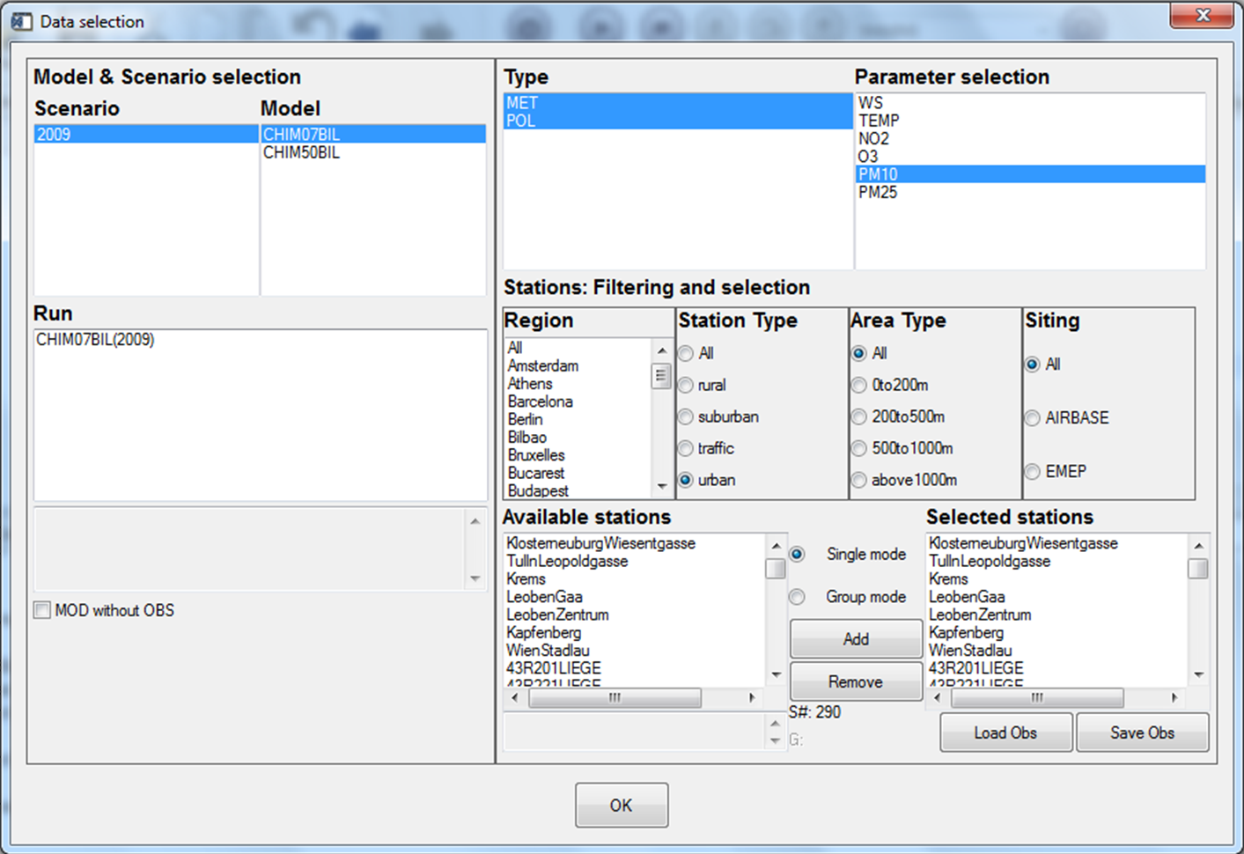

Figure 12: DELTA data selection interface.

### The analysis interface

The analysis interface (Figure 13) allows the user to select the type of statistics and diagram, as well as the desired temporal operations to be performed on the original data (“Time Avg” and “Daily Stats”). Available diagrams are described in the Diagram overview Section (Part III).

Each of these plot types can be selected to illustrate different statistical metrics (statistics column). This is especially true for the barplots which is the common way to visualise single statistical metrics (Mean, RMSE, bias, IOA, Exceedance days...). Some of these statistics require threshold values which can be included (e.g. SOMO, Exceedance days…) on the same window. The field for threshold values should contain numbers separated by an #.

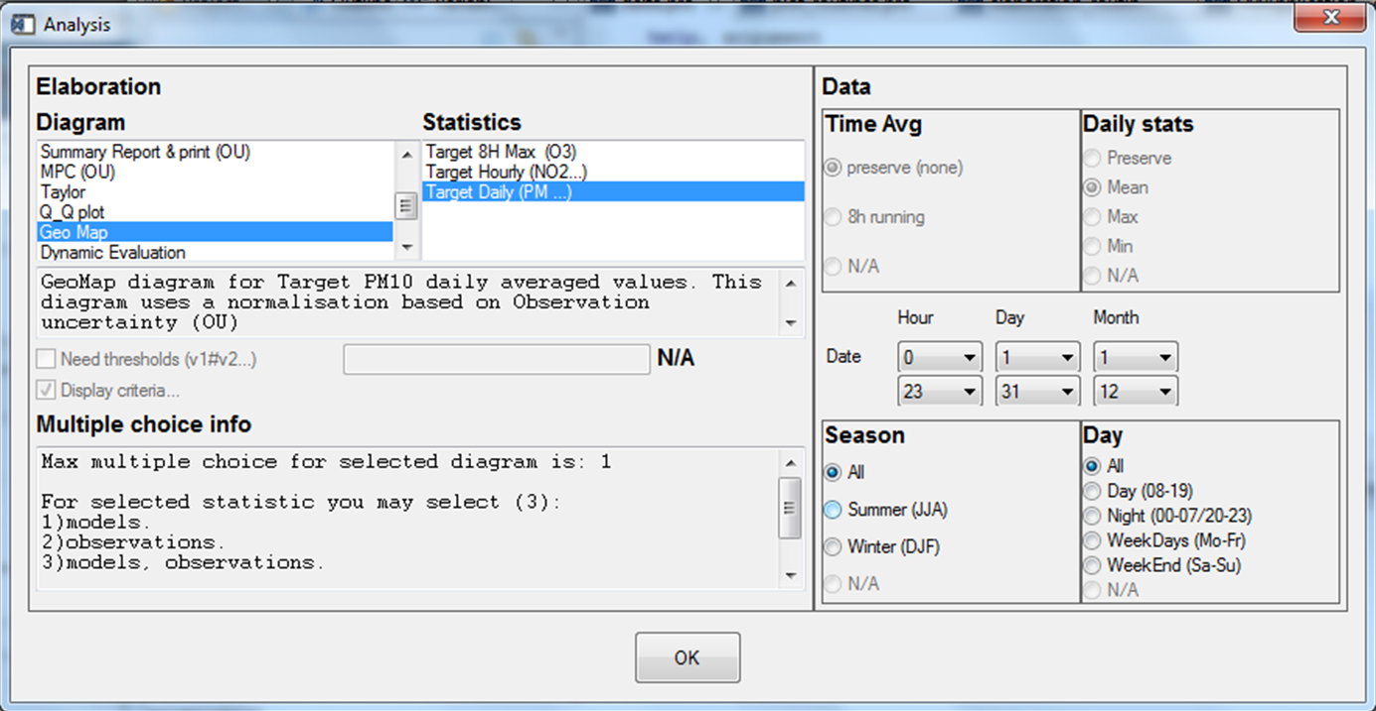

Figure : DELTA analysis selection interface

The lower left part of the analysis selection interface (“multiple choice info”) gives information on the different possibilities offered to the user in terms of combination of parameters, stations, and models to generate the diagram. These possibilities give the degree of freedom in selecting items of the four main entities: scenario (year); model; parameter; monitoring stations. The allowed multiple choices for a given diagram are pre-defined in the tool and are described in the Diagram overview Section.

On the right side of the analysis selection interface, time operations can be chosen to be performed on the selected modelled-observed data pairs, i.e.:

* **Time Avg**.: Time series kept as originally formatted (preserve or 1h) or 8h running average
* **Daily Stats**: Statistical operation applied for each day: mean, max or min.
* **Season**: choice between summer, winter and entire year
* **Day**: Selection between night time hours, daylight hours, entire 24h day, week-ends and week days.

Note that for some statistics and pollutant choices, these flags will be automatically filled to the adequate values.

This feature can be useful if you repeatedly use the same set of selections. In order to save the selections in the analysis window, use the top menu in Delta Tool: click the item “Analysis” and choose “Save Analysis” in the drop-down menu. A new window appears with the request to put a file name. File extension must be *.elb. By default the file is saved in the dir…. \save.To reload the saved selections, click the item “Analysis” on the top menu and choose “Restore Analysis”.

### The main graphical interface

When the user has made his selections in the data selection window and the analysis window the ‘Execute’ tab can be pressed. The Delta Tool’s main graphical interface will then pop-up (unless you have made selections that the tool does not support).

The screen is divided into two main areas:

* The left side recapitulates the choices made by the user in the previous interfaces which lead to the generation of a given diagram.
* The right side hosts the diagram and accompanying legend (which also summarizes the options selected by the user). Only one diagram is shown at a time (i.e. no multiple windows).

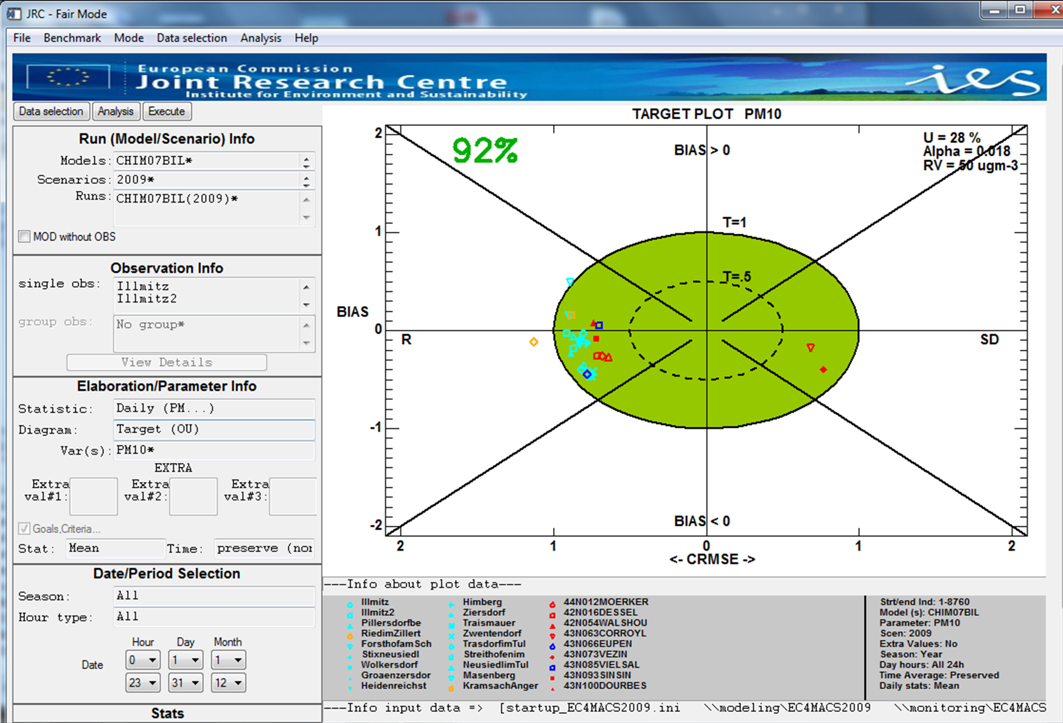

Figure : DELTA main graphical window.

## DELTA functionalities and user’s tuning options

### “Playing” with uncertainty parameters: the “goals_criteria_oc” input file

In the configuration file “goals_criteria_oc.dat” the user can find lines of the type:

3;PM10;ALL;OU;PMEAN;28*0.018*40*1*50*;Descr of: GC 56

Lines with “OU” as fourth parameter contain all information required to calculate the value of the observation uncertainty used to derive the model quality objectives for one particular species and time average. The numbers separated by asterisks can be modified by the user to test alternative uncertainty estimates. By order, these numbers represent (see equation 16 for details):

* (28 in our example) expressed in percentage. This is the expanded relative uncertainty ()
*  (0.018 in our example)
* Np and Nnp (40 and 1 in our example)
* RL the reference value (50 in our example)

**Testing different PM10 measurement uncertainties**

Different experimental methodologies exist to measure PM, each characterized by a different level of uncertainty. The user can test the impact of switching between different uncertainty estimates, corresponding to values representative of the gravimetric (default reference), beta-ray and teom techniques. In the “goals_criteria_oc.dat” configuration file, the following lines are visible:

26;PM10g;ALL;OU;PMEAN;28*0.018*40*1*50

27;PM10t;ALL;OU;PMEAN;38*0.027*40*1*50

28;PM10b;ALL;OU;PMEAN;38*0.009*40*1*50

To switch among the different PM uncertainty estimates it is necessary to copy the number in between asterisks for the selected uncertainty estimate (PM10g for gravimetric, PM10t for TEOM and PM10b for beta-ray) and use them in the PM10 line used by DELTA.

**Introducing uncertainties for new variables**

Two methodologies have been described in Sections 4.4 and 4.5. In the first case the user knows all required parameters and can introduce a new line at the end of the “goals_criteria_oc.dat” file as follows:

35;NEWSPEC;ALL;OU;PMEAN;28*0.018*40*1*50*;Descr of: GC 56

The first field is an index number which should increment the index of the previous line by 1. The second field should contain the name of the new species. Note that the same name should be kept in all monitoring, modeling and startup files for consistency. The third and fourth fields should be kept as is (i.e. ALL;OU). The fifth field (PMEAN) is a contraction of the time average (**P**reserve, **8H** running) and daily stat (**P**reserve, **MEAN**, **MAX** and **MIN**) options. The fifth field should concatenate the bold identified letters of the two options according to the choices made. For example O3 8h daily max would lead to “8HMAX” for the fifth field while daily PM10 would lead to “PMEAN”. The following five fields have been described above while the last field is a comment to be used at convenience by the user.

In section 4.5 an alternative methodology is described to set these uncertainty parameters. We provide here an example: assuming that we can estimate that the PM10 uncertainties around 0 and 50 ug/m3 would be 1.88 and 14 ug/m3, respectively. We can calculate easily the following numbers needed within DELTA.



### Saving summary statistics information in ASCII

Delta saves by default all information contained in each diagram in ASCII format by generating a file named “dumpFile.txt” which can be found in the dump directory. This file will be overwritten at each new generated diagram

Frequently used statistical indicators (e.g. correlation, bias…) can be automatically created by selecting the “summary report & print” analysis diagram option. DELTA will then generate the summary report in the graphical window but also create an ASCII file in the dump directory using the selected model and species to create the name.

Note that both options will create information relative to the selected time period.

### Mouse-driven recognize functionality

For most graphics a small additional window appears with the title “Info on data points (click!)”. This allows the user to click on the diagram and retrieve information about the quantitative values of the different points/stations represented. This feature can be switched on and off through the top menu in Delta Tool: click the item “Mode” and choose “Hide/Show Recognizer info”.

### Managing multiple datasets: the “MyDeltaInput” option

As mentioned before there are three different types of input information required to run the DELTA tool:

* The startup.ini file located in the ./resource directory
* The YEAR_MODEL_TIME.cdf file located in the ./data/modeling directory
* The station.csv files located in the ./data/monitoring directory

When dealing with different statup.ini files, different sets of modelling results, and different sets of monitoring stations, it may be useful to be able to overwrite the defaults locations of these three inputs.

The file *MyDeltaInput.dat* in the resource directory contains three lines:

1 - First line contains the name of the startup.ini file in the ./resource directory

2 - Second line contains the location of the model data in the ./data directory

3 - Third line contains the location of the monitoring data in the ./data directory

Example:

startupED2007.ini ; the startup.ini file

modelling_ED2007 ; subdirectory in ,/data

monitoring_ED2007 ; subdirectory in ./data

The default (if the MyDeltaInput.dat file is not found) is:

startup.ini

modeling

monitoring

After completion of ‘Execute’ the name of the used startup.ini file, the modelling data location, and the monitoring data location are mentioned beneath the plot.

Note that DELTA can run with/without this new configuration input file.

## Benchmarking mode

From the Delta Tool top menu select the item “Benchmarking” (this is only possible when the “Data Selection” window and the “Analysis” window are closed).

At present the automatic production of performance reports is available for the following pollutant concentrations and time frequencies:

* daily maximum 8h mean O3
* Daily averaged PM10
* Daily averaged PM25
* Hourly NO2
* Hourly WS
* Hourly TEMP
* Yearly PM10
* Yearly NO2

Reports are produced similar to those presented in Section 5 of the “Concepts” part of this document.

*Important*:

Currently the performance report is produced automatically for one single model. This single model is selected by default and corresponds to the top-of-the-list model when opening the data-selection interface. For applying the procedure to other models the user is requested to play with the model data files in the ../ data/modeling directory and leave in this directory only the model on which the performance report should be produced.

## Demo Dataset: Po-Valley

This dataset contains the results from a model inter-comparison exercise performed by two air quality models for year 2005. The model domain covers the Po Valley (Italy) with at 6 x6 km2 resolution (95x65 cells) grid. Pollutant concentrations have been simulated by 5 transport chemical (CHIMERE, TCAM, CAMX, RCG, MINNI ) of which two are made available in this demonstration dataset.

Observations from 63 monitoring sites located in the Po Valley are also provided. Sites have been classified in regions and station types (suburban, urban and rural).

## Utility programs

### Data-Check Integrity Tool

Aim:

Checking the consistency among the modeling results file (cdf, csv), the observation files (csv, cdf) and the main configuration file (startup.ini).

Important notes:

1. The data check integrity step will be performed automatically each time a new startup.ini is used. If modifications are made in the monitoring or modelling data without affecting the startup.ini file, please perform this data-check integrity manually to identify potential consistency issues.
2. If model data are in csv format, the data-check integrity tool will convert them in “cdf”.

How to use:

From the Delta Tool top menu select the item “Help” > “ Data-Check Integrity Tool” (this is only possible when the “Data Selection” window and the “Analysis” window are closed).

There are currently 18 steps included in this consistency check:

1. Checking existence of relevant directories
2. Checking existence of “startup.ini” file
3. Checking existence of appropriate sections within startup.ini
4. Checking correctness of “PARAMETERS” section within Startup.ini
5. Checking correctness of “MONITORING” section within Startup.ini
6. Checking for possible redundancy in station names in startup.ini
7. Checking consistency of the number of stations between startup.ini and obs files
8. Checking consistency of the station names between startup.ini and obs files
9. Checking consistency of the species names between startup.ini and obs files
10. Checking number of lines in obs files
11. Checking for extreme values in obs files
12. Checking for zero values (information check only)
13. Checking for existence of model file
14. Checking for correct attribute in model netCdf file
15. Checking correctness of time dimension in model file
16. Checking model extreme values
17. Checking consistency between species available in startup.ini and model file
18. Producing statistic report

Check_IO produces a log report, as well as a summary report with details concerning the various checks. The reports are located in the main directory where Delta Tool is installed.

### CSV to NetCDF

This tool available under the help menu allows to produce a model file in “cdf” format from files in csv format similar to the one described for monitoring data. This program works only for data produced with an hourly frequency. If model data are initially included in the data/modelling directory, conversion to “cdf” will automatically be performed at first use. If more than one models is used, this conversion operation will need to be activated manually for the other models.

### Preproc-CDF

The Deltapreprocessor is an idl-based tool for the extraction of time series at observational locations from meteorological or air quality model output for use in the DELTA Tool. Input to the PreProcessor is the configuration file 'startup.ini' containing the variables (meteorological variables , and pollutants) to be treated, as well as geographical information about the observational stations. Model output (i.e. input to the pre-processor) should be in netCDF format with all the variables defined on longitude-latitude coordinates at ground level and hourly frequency. Three interpolation techniques are available for producing the modeled time series at the observational stations:

(i) NN (Nearest Neighbour) where the values at a station are taken from the nearest lon-lat grid point.

(ii) BIL (Bilinear) where a bilinear interpolation is performed on the grid cell in which the station is located; for this the gridcell is first transformed into a square using a bilinear mapping.

(iii) DW (Distance Weighted) where a weighted mean value is calculation in the station grid-cell. The weights are the inverse of the distance from the station to the 4 gridpoints.

Output of the PreProcessor is written to a netCDF file.

During the PreProcessing a number of checks are performed to guarantee the conformity with the DELTA Tool conventions.

Part III

# DIAGRAMS Overview

In this section all diagrams/elaborations available in DELTA are detailed according to the following template:

|  |  |  |  |  |  |  |  |  |  |
| --- | --- | --- | --- | --- | --- | --- | --- | --- | --- |
| TEMPLATE: Diagram name (Elaboration name) | | | | | | | *Elaboration numbers (internal use)* | | |
|  | | | | | | | | | |
| DIAGRAM example | | | | | | | **X axis** | |  |
| **Y axis** | |  |
|  | | |
| **Parameters** | | Possible choice |
|  | | |
| **Time Avg** | | Possible options in the DELTA menu |
| **Daily Stats** | |
| **Season** | |
| **Day** | |
|  | | |
| **Threshold** | | Required or not |
|  | | |
| Description | Brief description of diagram | | | | | | | | |
|  | | | | | | | | | |
| MQO | If Model quality objective and/or model performance criteria are available for the diagram/elaboration a description of the criteria used is provided here. The list of parameters together with specific requirements (time averaging…) is also provided. If groups are allowed to be selected, this will as well be mentioned. | | | | | | | | |
|  | | | | | | | | | |
| Options | **O**BS | **M**OD | **P**AR | **S**CEN | Other |  | | Single  mode | Group  mode |
| Possible options in terms of multiple choices. A cross in OBS means that more than one station can be selected (similar for MOD, PAR and SCEN). If other options are available these will be mentioned under the “other” column. Foe example, O-M means that more than one model and more than one station can be selected at the same time. | | | | | Can single stations be selected? | Can station groups be selected? |

|  |  |  |  |  |  |  |  |  |  |
| --- | --- | --- | --- | --- | --- | --- | --- | --- | --- |
| BARPLOT (Mean, Stddev, Exc. Days) | | | | | | | *0,1,9* | | |
|  | | | | | | | | | |
|  | | | | | | | **X axis** | | Stations |
| **Y axis** | | Value |
|  | | |
| **Parameters** | | FREE |
|  | | |
| **Time Avg** | | FREE |
| **Daily Stats** | | FREE |
| **Season** | | FREE |
| **Day** | | FREE |
|  | | |
| **Threshold** | | Limit Value for Exc. days |
|  | | |
| Description | Bar-plots with observed values represented with grey filled bars. Modeled values are indicated with colored circles. In case of multiple choices involving three entities (e.g. models, observations and parameters), multiple bars will appear. | | | | | | | | |
|  | | | | | | | | | |
| MQO | N\A | | | | | | | | |
|  | | | | | | | | | |
| Options | **O**BS | **M**OD | **P**AR | **S**CEN | Other |  | | Single  mode | Group  mode |
| X | X | X | X | P-O  P-M  P-S  M-S  M-O  S-O  P-M-O  P-S-O  M-S-O | YES | YES |

|  |  |  |  |  |  |  |  |  |
| --- | --- | --- | --- | --- | --- | --- | --- | --- |
| BARPLOT (Spatial Correlation) | | | | | | | *14* | |
|  | | | | | | | | |
|  | | | | | | | **X axis** | Station Groups |
| **Y axis** | Value |
|  | |
| **Parameters** | FREE |
|  | |
| **Time Avg** | FREE |
| **Daily Stats** | FREE |
| **Season** | FREE |
| **Day** | FREE |
|  | |
| **Threshold** | N\A |
|  | |
| Description | For all stations included in a selected group (Note that this diagram only works with groups!) a time average value is calculated for the time period selected. All observed and modeled values within a given group are then correlated to each other to provide a single value per selected group of stations. | | | | | | | |
|  | | | | | | | | |
| MQO | N\A | | | | | | | |
|  | | | | | | | | |
| Options | **O**BS | **M**OD | **P**AR | **S**CEN | Other |  | Single  mode | Group  mode |
| X | X | X | X | P-O  M-O |  | NO | YES |

|  |  |  |  |  |  |  |  |  |  |
| --- | --- | --- | --- | --- | --- | --- | --- | --- | --- |
| BARPLOT (R, Mbias, RMSE, IOA, RDE, NMB, RPE, FAC2, NMSD) | | | | | | | *2, 3, 4, 7, 8, 23, 30, 33, 54* | | |
|  | | | | | | | | | |
|  | | | | | | | **X axis** | | Stations |
| **Y axis** | | Values |
|  | | |
| **Parameters** | | FREE |
|  | | |
| **Time Avg** | | FREE |
| **Daily Stats** | | FREE |
| **Season** | | FREE |
| **Day** | | FREE |
|  | | |
| **Threshold** | | N|A |
|  | | |
| Description | For all stations the selected characteristic is plotted as a colored circle. In case of multiple choice involving two entities (e.g. models and observations) two colored circles will appear while for multiple choice involving three entities (e.g. models, parameters and observations) multiple bars will appear. | | | | | | | | |
|  | | | | | | | | | |
| MQO | N|A | | | | | | | | |
|  | | | | | | | | | |
| Options | **O**BS | **M**OD | **P**AR | **S**CEN | Other |  | | Single  mode | Group  mode |
| X | X | X | X | P-O  P-M  P-S  M-S  M-O  S-O  P-M-O  P-S-O  M-S-O |  | | YES | YES |

|  |  |  |  |  |  |  |  |  |  |
| --- | --- | --- | --- | --- | --- | --- | --- | --- | --- |
| BARPLOT (CUMUL) | | | | | | | *38* | | |
|  | | | | | | | | | |
|  | | | | | | | **X axis** | | Stations |
| **Y axis** | | Values |
|  | | |
| **Parameters** | | FREE |
|  | | |
| **Time Avg** | | FREE |
| **Daily Stats** | | FREE |
| **Season** | | FREE |
| **Day** | | FREE |
|  | | |
| **Threshold** | | Offset value |
|  | | |
| Description | For all stations the cumulative total of the selected variable is plotted. This option is useful for deposition variables like rain or deposited pollutants. The total is the sum of the hourly values over the selected period of time, In case of multiple choice involving two entities (e.g. models and observations) two colored circles will appear while for multiple choice involving three entities (e.g. models, parameters and observations) multiple bars will appear.  Take offset value equal to 0.  Example gives quantity of rain at some Spanish stations in 1000*mm/m2 over the period 25/02/2009 – 26/03/2009 | | | | | | | | |
|  | | | | | | | | | |
| MQO | N|A | | | | | | | | |
|  | | | | | | | | | |
| Options | **O**BS | **M**OD | **P**AR | **S**CEN | Other |  | | Single  mode | Group  mode |
| X | X | X | X | P-O  P-M  P-S  M-S  M-O  S-O  P-M-O  P-S-O  M-S-O |  | | YES | YES |

|  |  |  |  |  |  |  |  |  |  |  |  |  |  |
| --- | --- | --- | --- | --- | --- | --- | --- | --- | --- | --- | --- | --- | --- |
| SCATTER (Mean mod vs. mean obs) | | | | | | | | | *6* | | | | |
|  | | | | | | | | | | | | | |
|  | | | | | | | | | **X axis** | | Mean Observations | | |
| **Y axis** | | Mean Model values | | |
|  | | | | |
| **Parameters** | | | FREE | |
|  | | | | |
| **Time Avg** | | | FREE | |
| **Daily Stats** | | | FREE | |
| **Season** | | | FREE | |
| **Day** | | | FREE | |
|  | | | | |
| **Threshold** | | | N/A | |
|  | | | | |
| Description | The scatter diagram plots mean modeled values against mean measurements. If only one model, one parameter and one scenario selected, different symbols and colors are used to represent the different stations. Otherwise dots are used for each station (or group of stations) with colors depending on scenario, model or parameter (see example). | | | | | | | | | | | | |
|  | | | | | | | | | | | | | |
| MQO | Dashed and solid lines indicate NMB/2RMSU ratios of 0.5 and 1, respectively. The orange region (only for hourly/daily) delimited by ratio sqrt(0.5)=0.71 (see Concepts equations (10 to (12)) | | | | | | | | | | | | |
| MQO are valid for the following parameters/ time statistic choices | | | | | | | | | | | | |
| *Parameter* | | | *Time Avg* | | | | *Daily Stats* | | *Season* | | *Day* | *Group* |
| PM10 | | | preserve | | | | Mean | | Free | | N/A | NO |
| PM25 | | | preserve | | | | Mean | | Free | | N/A | NO |
| O3 | | | 8H | | | | Max | | Free | | N/A | NO |
| NO2 | | | preserve | | | | preserve | | Free | | Free | NO |
| WS | | | Preserve | | | | Preserve | | Free | | Free | NO |
| TEMP | | | Preserve | | | | Preserve | | Free | | Free | NO |
|  | | | | | | | | | | | | | |
| Options | **O**BS | **M**OD | **P**AR | | **S**CEN | Other |  | | Single  mode | | | Group  mode | |
| X | X | X | | X | O-M  O-P |  | | YES | | | YES | |

|  |  |  |  |  |  |  |  |  |  |  |  |  |  |
| --- | --- | --- | --- | --- | --- | --- | --- | --- | --- | --- | --- | --- | --- |
| SCATTER (One station – All time values) | | | | | | | | | *13* | | | | |
|  | | | | | | | | | | | | | |
| F:\DELTA\S1.bmp | | | | | | | | | **X axis** | | Observations | | |
| **Y axis** | | Model values | | |
|  | | | | |
| **Parameters** | | | FREE | |
|  | | | | |
| **Time Avg** | | | N/A | |
| **Daily Stats** | | | N/A | |
| **Season** | | | FREE | |
| **Day** | | | N/A | |
|  | | | | |
| **Threshold** | | | N/A | |
|  | | | | |
| Description | The scatter diagram plots all time modeled values against measurements for one single station/group selected. If a group is selected, the average of all station values at each time are averaged and plotted against the corresponding modeled value. | | | | | | | | | | | | |
|  | | | | | | | | | | | | | |
| MQO | Dashed and solid lines indicate NMB/2RMSU ratios of 0.5 and 1, respectively. The orange region (only for hourly/daily) delimited by ratio sqrt(0.5)=0.71 (see Concepts equations (10 to (12)) | | | | | | | | | | | | |
| MQO are valid for the following parameters/ time statistic choices | | | | | | | | | | | | |
| *Parameter* | | | *Time Avg* | | | | *Daily Stats* | | *Season* | | *Day* | *Group* |
| PM10 | | | preserve | | | | Mean | | Free | | N/A | NO |
| PM25 | | | preserve | | | | Mean | | Free | | N/A | NO |
| O3 | | | 8H | | | | Max | | Free | | N/A | NO |
| NO2 | | | preserve | | | | preserve | | Free | | Free | NO |
| WS | | | Preserve | | | | Preserve | | Free | | Free | NO |
| TEMP | | | Preserve | | | | Preserve | | Free | | Free | NO |
|  | | | | | | | | | | | | | |
| Options | **O**BS | **M**OD | **P**AR | | **S**CEN | Other |  | | Single  mode | | | Group  Mode | |
| X | X | X | | X | O-M  O-P |  | | YES | | | NO | |

|  |  |  |  |  |  |  |  |  |
| --- | --- | --- | --- | --- | --- | --- | --- | --- |
| TIME SERIES | | | | | | | *12* | |
|  | | | | | | | | |
|  | | | | | | | **X axis** | Time |
| **Y axis** | Values |
|  | |
| **Parameters** | FREE |
|  | |
| **Time Avg** | FREE |
| **Daily Stats** | FREE |
| **Season** | FREE |
| **Day** | FREE |
|  | |
| **Threshold** | N\A |
|  | |
| Description | Plot of the time series for observations and model results at 1 station for 1 or more models and scenarios. The 75% minimum coverage of the data is not taken into account here, all values are plotted. | | | | | | | |
|  | | | | | | | | |
| MQO | N/A | | | | | | | |
|  | | | | | | | | |
| Options | **O**BS | **M**OD | **P**AR | **S**CEN | Other |  | Single  Mode | Group  mode |
|  | X |  | X |  |  | YES | NO |

|  |  |  |  |  |  |  |  |  |  |  |  |  |  |
| --- | --- | --- | --- | --- | --- | --- | --- | --- | --- | --- | --- | --- | --- |
| TARGET (8H Max, Daily, Hourly) | | | | | | | | | *21,52,81* | | | | |
|  | | | | | | | | | | | | | |
| F:\Target.bmp | | | | | | | | | **X axis** | | CRMSE / 2RMSU | | |
| **Y axis** | | BIAS / 2RMSU | | |
|  | | | | |
| **Parameters** | | NO2, O3, PM10 | | |
|  | | | | |
| **Time Avg** | | See MQO below | | |
| **Daily Stats** | |
| **Season** | |
| **Day** | |
|  | | | | |
| **Threshold** | | N/A | | |
|  | | | | |
| Description | The Target diagram plots for each station the normalized CRMSE against the normalized BIAS. The distance from the origin represents the normalized RMSE. The screen is divided into [four areas](#_Target_Diagram_(Fig2) distinguishing the main source of error type for each station (Negative and positive bias, correlation (R), and standard deviation (SD). Different symbols and colors are used to represent the different stations.  The CRMSE related error is examined to see whether it is dominated by R or by SD. The following ratio is used to assign a given station either to the left or right side of the target diagram (see METHOD2012 for more details) | | | | | | | | | | | | |
|  | | | | | | | | | | | | | |
| MQO | Dashed and solid lines indicate RMSE/2RMSU ratios of 0.5 and 1, respectively. The number of stations fulfilling RMSE/2RMSU < 1 is indicated in the upper left part of the diagram and should be larger than 90%. The Target diagram is only available with associated MQO (see below). This diagram is not available for yearly average values. More details can be found in [Concepts Section 5.1](#_Target_Diagram_(Fig2). | | | | | | | | | | | | |
| MQO are valid for the following parameters/ time statistic choices | | | | | | | | | | | | |
| *Parameter* | | | *Time Avg* | | | | *Daily Stats* | | *Season* | | *Day* | *Group* |
| O3 | | | 8H | | | | Max | | Free | | N/A | 90% |
| NO2 | | | Preserve | | | | Preserve | | Free | | Free | 90% |
| PM10 | | | Preserve | | | | Mean | | Free | | N/A | 90% |
| PM25 | | | Preserve | | | | Mean | | Free | | N/A | 90% |
| WS | | | Preserve | | | | Preserve | | Free | | Free | 90% |
| TEMP | | | Preserve | | | | Preserve | | Free | | Free | 90% |
|  | | | | | | | | | | | | | |
| Options | **O**BS | **M**OD | **P**AR | | **S**CEN | Other |  | | Single  Mode | | | Group  mode | |
| X | X |  | |  | O-M |  | | Yes | | | Only 90% option | |

|  |  |  |  |  |  |  |  |  |  |  |  |  |  |  |
| --- | --- | --- | --- | --- | --- | --- | --- | --- | --- | --- | --- | --- | --- | --- |
| SUMMARY REPORT (8H Max, Daily, Hourly) | | | | | | | | | *31,83,84* | | | | | |
|  | | | | | | | | | | | | | | |
| F:\sumRday.bmp | | | | | | | | | **X axis** | | | N/A | | |
| **Y axis** | | | N/A | | |
|  | | | | | |
| **Parameters** | | | O3, PM10,NO2 | | |
|  | | | | | |
| **Time Avg** | | | See MQO below | | |
| **Daily Stats** | | |
| **Season** | | |
| **Day** | | |
|  | | | | | |
| **Threshold** | | | | Used for exceedance calculation | |
|  | | | | | |
| Description | The summary report is available for both hourly and yearly frequency (in this case a simplified version is produced). All details can be found in Section 5.1and 5.2 | | | | | | | | | | | | | |
|  | | | | | | | | | | | | | | |
| MQO | For details on how green and orange areas are defined, see Section 4.2. | | | | | | | | | | | | | |
| MQO are valid for the following parameters/ time statistic choices | | | | | | | | | | | | | |
| *Parameter* | | | *Time Avg* | | | | *Daily Stats* | | | *Season* | | *Day* | *Group* |
| O3 | | | 8H | | | | Max | | | Free | | N/A | NO |
| NO2 | | | Preserve | | | | Preserve | | | Free | | Free | NO |
| PM10 | | | Preserve | | | | Mean | | | Free | | N/A | NO |
| PM25 | | | Preserve | | | | Mean | | | Free | | N/A | NO |
| WS | | | Preserve | | | | Preserve | | | Free | | Free | NO |
| TEMP | | | Preserve | | | | Preserve | | | Free | | Free | NO |
|  | | | | | | | | | | | | | | |
| Options | **O**BS | **M**OD | **P**AR | | **S**CEN | Other |  | | | Single  mode | | | Group  mode | |
| X |  |  | |  |  |  | | | YES | | | NO | |

|  |  |  |  |  |  |  |  |  |  |  |  |  |  |  |
| --- | --- | --- | --- | --- | --- | --- | --- | --- | --- | --- | --- | --- | --- | --- |
| MPC correlation (8H Max, Daily, Hourly) | | | | | | | | | *15,16,78* | | | | | |
|  | | | | | | | | | | | | | | |
| F:\DELTA\S2.bmp | | | | | | | | | **X axis** | | | RMSU/σO | | |
| **Y axis** | | | R | | |
|  | | | | | |
| **Parameters** | | | O3, PM10, NO2 | | |
|  | | | | | |
| **Time Avg** | | | See MQO below | | |
| **Daily Stats** | | |
| **Season** | | |
| **Day** | | |
|  | | | | | |
| **Threshold** | | | N\A | | |
|  | | | | | |
| Description | This diagram plots correlation as function of the quadratic mean of the uncertainty divided by the station observed standard deviation. It provides for each station (represented by a symbol) an indication of whether the time correlation fulfills a minimum level of quality (green/orange area) | | | | | | | | | | | | | |
|  | | | | | | | | | | | | | | |
| MQO | For details on how green and orange areas are defined, see Concepts equations (10 to 12). | | | | | | | | | | | | | |
| MQO are valid for the following parameters/ time statistic choices | | | | | | | | | | | | | |
| *Parameter* | | | *Time Avg* | | | | *Daily Stats* | | *Season* | *Day* | | | *Group* |
| O3 | | | 8H | | | | Max | | Free | N/A | | | 90% |
| NO2 | | | Preserve | | | | Preserve | | Free | Free | | | 90% |
| PM10 | | | Preserve | | | | Mean | | Free | N/A | | | 90% |
| PM25 | | | Preserve | | | | Mean | | Free | N/A | | | 90% |
| WS | | | Preserve | | | | Preserve | | Free | Free | | | 90% |
| TEMP | | | Preserve | | | | Preserve | | Free | Free | | | 90% |
|  | | | | | | | | | | | | | | |
| Options | **O**BS | **M**OD | **P**AR | | **S**CEN | Other |  | | Single  mode | | | | Group  mode | |
| X | X |  | |  | M-O |  | | YES | | | | YES | |

|  |  |  |  |  |  |  |  |  |  |  |  |  |  |
| --- | --- | --- | --- | --- | --- | --- | --- | --- | --- | --- | --- | --- | --- |
| MPC std. Dev. (8H Max, Daily, Hourly) | | | | | | | | | *25,32,79* | | | | |
|  | | | | | | | | | | | | | |
| F:\DELTA\S3.bmp | | | | | | | | | **X axis** | | RMSU/σO | | |
| **Y axis** | | NMSD | | |
|  | | | | |
| **Parameters** | | O3, PM10, NO2 | | |
|  | | | | |
| **Time Avg** | | See MQO below | | |
| **Daily Stats** | |
| **Season** | |
| **Day** | |
|  | | | | |
| **Threshold** | | N\A | | |
|  | | | | |
| Description | This diagram plots NMSD as function of the quadratic mean of the uncertainty divided by the station observed standard deviation. It provides for each station (represented by a symbol) an indication of whether the normalized standard deviation (NMSD) fulfills a minimum level of quality. | | | | | | | | | | | | |
|  | | | | | | | | | | | | | |
| MQO | For details on how green and orange areas are defined, see Concepts equations (10 to 12). | | | | | | | | | | | | |
| MQO are valid for the following parameters/ time statistic choices | | | | | | | | | | | | |
| *Parameter* | | | *Time Avg* | | | | *Daily Stats* | | *Season* | | *Day* | *Group* |
| O3 | | | 8H | | | | Max | | Free | | N/A | 90% |
| NO2 | | | Preserve | | | | Preserve | | Free | | N/A | 90% |
| PM10 | | | Preserve | | | | Mean | | Free | | Free | 90% |
| PM25 | | | Preserve | | | | Mean | | Free | | Free | 90% |
| WS | | | Preserve | | | | Preserve | | Free | | Free | 90% |
| TEMP | | | Preserve | | | | Preserve | | Free | | Free | 90% |
|  | | | | | | | | | | | | | |
| Options | **O**BS | **M**OD | **P**AR | | **S**CEN | Other |  | | Single  mode | | | Group  mode | |
| X | X |  | |  | M-O |  | | YES | | | YES | |

|  |  |  |  |  |  |  |  |  |  |  |
| --- | --- | --- | --- | --- | --- | --- | --- | --- | --- | --- |
| Taylor | | | | | | | *19* | | | |
|  | | | | | | | | | | |
|  | | | | | | | **X axis** | | σM/σO | |
| **Y axis** | | σM/σO | |
|  | | | |
| **Parameters** | | FREE | |
|  | | | |
| **Time Avg** | | FREE | |
| **Daily Stats** | | FREE | |
| **Season** | | FREE | |
| **Day** | | FREE | |
|  | | | |
| **Threshold** | | N\A | |
|  | | | |
| Description | The Taylor diagram provides for each station an indication on Correlation (angular distance), standard deviation (model standard deviation larger than observed one when the station symbol lies beyond the dashed line) and CRMSE (distance between the station symbol and the black asterisk on the X axis. | | | | | | | | | |
|  | | | | | | | | | | |
| MQO | N/A | | | | | | | | | |
|  | | | | | | | | | | |
| Options | **O**BS | **M**OD | **P**AR | **S**CEN | Other |  | | Single  mode | | Group  mode |
| X | X | X |  | P-O  M-O |  | | YES | | YES |

|  |  |  |  |  |  |  |  |  |  |  |
| --- | --- | --- | --- | --- | --- | --- | --- | --- | --- | --- |
| Q-Q plot (One station All values) | | | | | | | *29* | | | |
|  | | | | | | | | | | |
|  | | | | | | | **X axis** | | Observed | |
| **Y axis** | | Modelled | |
|  | | | |
| **Parameters** | | FREE | |
|  | | | |
| **Time Avg** | | FREE | |
| **Daily Stats** | | FREE | |
| **Season** | | FREE | |
| **Day** | | FREE | |
|  | | | |
| **Threshold** | | N/A | |
|  | | | |
| Description | Same as scatter but both observed and modeled values are independently sorted. | | | | | | | | | |
|  | | | | | | | | | | |
| MQO | N\A | | | | | | | | | |
|  | | | | | | | | | | |
| Options | **O**BS | **M**OD | **P**AR | **S**CEN | Other |  | | Single  mode | | Group  mode |
|  | X | X |  |  |  | | YES | | NO |

|  |  |  |  |  |  |  |  |  |  |  |
| --- | --- | --- | --- | --- | --- | --- | --- | --- | --- | --- |
| Dynamic evaluation (Day-Night) | | | | | | | *71* | | | |
|  | | | | | | | | | | |
|  | | | | | | | **X axis** | | Observed day/ night difference | |
| **Y axis** | | Modeled day/ night difference | |
|  | | | |
| **Parameters** | | FREE | |
|  | | | |
| **Time Avg** | | FREE | |
| **Daily Stats** | | FREE | |
| **Season** | | FREE | |
| **Day** | | FREE | |
|  | | | |
| **Threshold** | | N/A | |
|  | | | |
| Description | Scatter plots of modeled vs. observed day-night mean differences. Well behaving results should lie along the 1 to 1 line. Lower right and upper left part of the graphs indicate poor results. | | | | | | | | | |
|  | | | | | | | | | | |
| MQO | N\A | | | | | | | | | |
|  | | | | | | | | | | |
| Options | **O**BS | **M**OD | **P**AR | **S**CEN | Other |  | | Single  mode | | Group  mode |
| X | X | X |  |  |  | | YES | | YES |

|  |  |  |  |  |  |  |  |  |  |  |
| --- | --- | --- | --- | --- | --- | --- | --- | --- | --- | --- |
| Dynamic evaluation (Summer-Winter) | | | | | | | *72* | | | |
|  | | | | | | | | | | |
|  | | | | | | | **X axis** | | Observed day/ night difference | |
| **Y axis** | | Modeled day/ night difference | |
|  | | | |
| **Parameters** | | FREE | |
|  | | | |
| **Time Avg.** | | FREE | |
| **Daily Stats** | | FREE | |
| **Season** | | FREE | |
| **Day** | | FREE | |
|  | | | |
| **Threshold** | | FREE | |
|  | | | |
| Description | Scatter plots of modeled vs. observed day-night mean differences. Well behaving results should lie along the 1 to 1 line. Lower right and upper left part of the graphs indicate poor results. | | | | | | | | | |
|  | | | | | | | | | | |
| MQO | N/A | | | | | | | | | |
|  | | | | | | | | | | |
| Options | **O**BS | **M**OD | **P**AR | **S**CEN | Other |  | | Single  mode | | Group  mode |
| X | X | X |  |  |  | | YES | | YES |

|  |  |  |  |  |  |  |  |  |  |  |
| --- | --- | --- | --- | --- | --- | --- | --- | --- | --- | --- |
| Dynamic evaluation (Weekdays – Weekends) | | | | | | | *73* | | | |
|  | | | | | | | | | | |
|  | | | | | | | **X axis** | | Observed weekdays/ week-end difference | |
| **Y axis** | | Modeled weekdays/ week-end difference | |
|  | | | |
| **Parameters** | | FREE | |
|  | | | |
| **Time Avg** | | FREE | |
| **Daily Stats** | | FREE | |
| **Season** | | FREE | |
| **Day** | | FREE | |
|  | | | |
| **Threshold** | | N\A | |
|  | | | |
| Description | Scatter plots of modeled vs. observed day-night mean differences. Well behaving results should lie along the 1 to 1 line. Lower right and upper left part of the graphs indicate poor results. | | | | | | | | | |
|  | | | | | | | | | | |
| MQO | N/A | | | | | | | | | |
|  | | | | | | | | | | |
| Options | **O**BS | **M**OD | **P**AR | **S**CEN | Other |  | | Single  mode | | Group  mode |
| X | X | X |  |  |  | | YES | | YES |

|  |  |  |  |  |  |  |  |  |  |  |
| --- | --- | --- | --- | --- | --- | --- | --- | --- | --- | --- |
| GeoMap (Target) | | | | | | | *35,36,37* | | | |
|  | | | | | | | | | | |
| F:\geomap.bmp | | | | | | | **X axis** | | N\A | |
| **Y axis** | | N\A | |
|  | | | |
| **Parameters** | | O3, NO2, PM10 | |
|  | | | |
| **Time Avg** | | FREE | |
| **Daily Stats** | | FREE | |
| **Season** | | FREE | |
| **Day** | | FREE | |
|  | | | |
| **Threshold** | |  | |
|  | | | |
| Description | GeoMap map showing the locations of the selected stations, together with the Target value for O3 (8hr mean), hourly NO2, daily PM10, hourly WS and TEMP. Colors indicate whether or not the uncertainty criterium is satisfied yes or no; and if not satisfied the location in the target (Bias >0, Bias <0, Correlation dominated or NMSD dominated | | | | | | | | | |
|  | | | | | | | | | | |
| MQO | For details, see Section 4.2. | | | | | | | | | |
|  | | | | | | | | | | |
| Options | **O**BS | **M**OD | **P**AR | **S**CEN | Other |  | | Single  Mode | | Group  mode |
|  | X | X |  |  |  | | YES | | NO |

|  |  |  |  |  |  |  |  |  |  |  |  |
| --- | --- | --- | --- | --- | --- | --- | --- | --- | --- | --- | --- |
| Google Earth (Mean, Exc. Days, Bias, NMB, Std. Dev, R, RMSE, RDE, σM/σO, NMSD) | | | | | | | *58,59,60,61,62,*  *63, 64,67,68,69* | | | | |
|  | | | | | | | | | | | |
|  | | | | | | | | | **X axis** | N\A | |
| **Y axis** | N\A | |
|  | | |
| **Parameters** | FREE | |
|  | | |
| **Time Avg** | FREE | |
| **Daily Stats** | FREE | |
| **Season** | FREE | |
| **Day** | FREE | |
|  | | |
| **Threshold** | See explanations in Analysis window | |
|  | | |
| Description | Google Earth map showing the locations of the selected stations, as well as all requested observational and model results in pop-up windows. The location of the GE application must be inserted in the init.ini file in the resource directory | | | | | | | | | | |
|  | | | | | | | | | | | |
| MQO |  | | | | | | | | | | |
|  | | | | | | | | | | | |
| Options | **O**BS | **M**OD | **P**AR | **S**CEN | Other |  | | Single  Mode | | | Group  mode |
| X | X | X | X |  |  | | YES | | | NO |